Are Changing Angular Velocity Magnetic Fields a Countermeasure to Havana Syndrome and other Pulsed Modulated Frequency Cyberattacks?
1
By Michael J. McCarron, 2021 (independent cybersecurity consultant, macciarain@protonmail.com)

[pre-press, rough draft]

Abstract: The following is a review of studies related to Ahronov-Bohm (A-B) Generators known in the Soviet Union as Akimov Generators. I argue that Soviet military-industrial technology is the cause of Havana Syndrome. I take the results of Verma et al (2019) fMRI measurements of white and gray brain matter and compare them to the findings of Kernbach and Persinger et al studies on A-B Generators and their effects on the human brain using sLORETA, and QEEG measurements, with particular attention to Rouleau (2015b) measurement of non-local Harribance configuration impact on gray matter. I argue the brain areas affected by A-B based weapons correlate between the two approaches to show a quantifiable evidence of extrinsic attack on the biology of targets, that specific brain areas are involved and can be used to profile such an A-B exploit.

Contents:

Section I: Profiling a Directed Energy Attack Medically Speaking
Section II: Technological Briefing (A-B Effect, Casimir Effect, Gravito-electromagnetics, etc)
Section III: Brain Profile: Havana Syndrome, Epilepsy and Non-Local EEG Studies

Medical Pathology of Non-Local Weapons

In the following I provide documentation on the physics of Ahronov-Bohm Effect weapons technology and neurological effects from these physics as it interacts with the interferometer known as the human brain. This is a review work that provides documentation for the A-B Cybersecurity Device developed to counter non-local weapons (McCarron, 2021b). The physiology of those attacked by RF based weapons in the US Embassy in Havana provides one of the first efforts at medically studying the use of directed waves against a human target. After this I go into the use of entanglement and the physics of entanglement focusing on angular momentum and the utilization of the Ahronov-Bohm effect and Dynamical Casimir Effect, including it’s Gravitational corollary to the EM version, covering also gravito-electromagnetism- the coupling of gravity and EM, which produces photon emissions which is suggested by some researchers as that along with gravitons as the boson involved in entanglement or deep correlations which is the physical basis of these weapons. Then I show that this work was begun in the Soviet Union and then transferred to the defense industry of the United States of America as well as other NATO members, proliferating into the Black Market. After showing the neurological effects, then understanding the science behind the technology we can then correlate studies on A-B effect regarding Neurological effects to specific areas of the Brain affected in terms of functionality as studied by fMRI and QEEG by the Verma et al and Persinger Group cross correlated to changes studied in the Havana Syndrome medical studies.

I. Profiling a Directed Energy Attack Medically Speaking

Havana Syndrome

Havana Syndrome is a popular term coined to refer to the illnesses experienced by diplomats at the US Embassy in Havana, Cuba in 2016. It is similar to incidents at the Moscow US Embassy of 2.4-4.0Ghz from 1953 to 1976. Kravkov notes the use of mm waves for biological weapons development starting in the Soviet Union in 1973 (Kravkov, 2006). Another incident was reported in Guangzhou, China also at a US Embassy in 2018. The same illnesses were reported by Russian politician Boris Yeltsin (Kernbach, 2017) in the early 1990s during the break up of the Soviet Union and attempted coup by Communist Generals. Scientists studying the phenomenon cite microwaves (mm waves) as the culprit, directed pulsed Radio Frequency weapons. Whereas critics dismiss the use of highly sensitive technology to militaries around the world calling the situation a case of mass psychogenic illness, which fits well with a disinformation campaign to keep highly classified technology top secret. There is a general pattern of labeling any serious researchers in this area that are outside military control as pseudoscientists, for instance see the case of Akimov (McCarron, 2021, Ch. 8), former Soviet scientist then denounced as a pseudo-scientist after disclosure of the Soviet military technology.
Neurologists at the University of Pennsylvania (Verma et al, 2019) studied the brains of embassy staff from the Havana incidents. All professional diplomats and military personnel who complained of the following symptoms:

Balance problems, tinnitus, hearing strange grating noises, headache, hearing loss, memory loss, and nausea

These symptoms can also occur when working near Radar installations as reported by military technicians since the inception of Radar. Verma et als (2019) Neuroimaging studies focused on the change in white matter and gray matter volumes of the attacked individuals compared to controls the main area affected was the right hemisphere, specifically altering the auditory: Right and Left Superior Temporal Gyrus, Heschl’s Gyrus (BA 22, 48); Right Thalamus and visual-spatial subnets: R & L Frontal Gyrus, Superior Frontal Gyrus, Precentral Gyrus (BA 6); R & L Inferior Parietal Sulcus (BA 2, 40, 7); R & L Frontal Operculum, IFG (BA 44,45, 48) R & L Temporal Gyrus (BA 37), also involved in vision is the Cuneus (BA 17). Finding a difference of whole brain white matter volume, regional gray and white matter volume, mainly in the right hemisphere. The Cerebellar tissue micro-structural integrity was damaged. Functional connectivity in the auditory/visual-spatial subnets was reduced. The study does not address a specific causality although they do believe that some of form of pulsed directed microwaves were involved. The researchers note that: “the clinical importance of these differences is uncertain and may require further study.” (Verma et al, 2019)

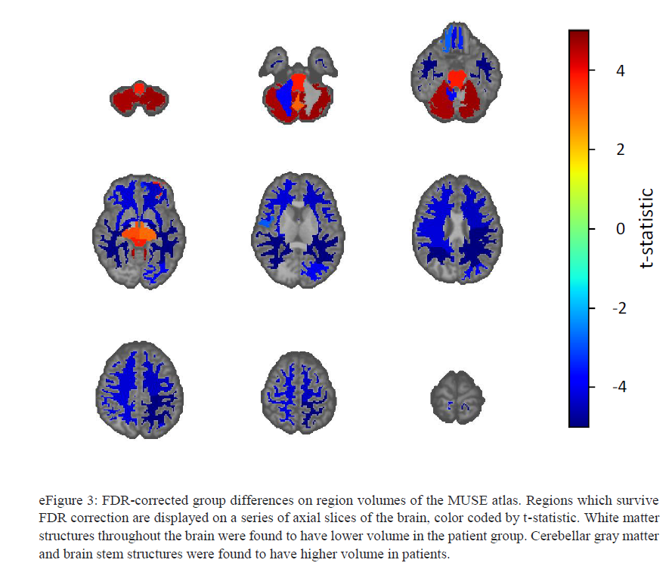
(Verma et al, 2019, Supplemental Materials)

As shall be seen later the area of BA 22 was involved in early Soviet and later Russian research as well as those scientists employment with western companies such as Lockheed-Martin (see Norseen et al, 1999). An additional area affected was the volume differences between right and left ventral diencephalon, the caudal (posterior) part of the forebrain containing the thalamus, hypothalamus and ventral thalamus and the third ventricle. Further, they found higher mean fractional anisotropy, the property of substances to exhibit variations in physical properties along different molecular axes (i.e. crystals, H₂O).
In the supplementary information provided in their study Table 7 provides some of the areas of the brain that have high levels of differentiation from the control group.

Brain organelles with large difference from normative values of brain morphology:
- Cuneus, receives visual information from the senses, retina. Broadmann Area 17.

- Anterior Insula, involved in consciousness, salience, emotion, homeostasis, compassion/empathy, taste, perception, self-awareness, cognitive function interpersonal experience-- involved in psychopathology, connects to the Amygdala. Loss of Balance and vertigo in people with lesions in the insula. The posterior insula processes auditory detection, simple auditory hallucinations were elicited by electrical functional stimulation. It has no Broadmann area as it covers a large area. 2 Spontaneous activity fluctuations in anterior insular cortex influence auditory perception (Sterzer, 2010)

- Putamen, Broadman Area 8, regulate movements at various stages (preparation , execution and influences learning. Neurotransmitters GABA, acetylcholine, encaphalin, dopamine. It receives serotonin, glutamate. It is part of the “hate circuit” along with the insula . In Male-to-Female Trans people this area has significantly larger gray matter.

- Post-Central Gyrus, Broadmann Area 1,2,3. Somatosensory cortex, part of Default Network, contains a sensory strip representing the lower part of the body, contains an inverted map of the contralateral body mirroring the motor strip. Senses touch, pressure, pain, temperature. TMS [and probably Transcerebral Magnetic Stimulation yet tested for proof of effect] improves tactile discrimination and reorganizes the somatosensory map, also affects pain modulation.

- Middle Temporal Gyrus (BA 21, part of Temporal Lobe: BA 20,21,22, measured by EEG C4) Functions for object vision, recognition, facial recognition.

- Triangular part of the Inferior Frontal Gyrus (BA 45, part of Broca’s Area as cited by Norseen below), part of the IFG: BA 44,45,47 Semantic processing, associated with N400 waves in EEG. Part of the VLPFC (ventrolateral prefrontal cortex) [related to hypnosis, (McCarron 2021, Ch.11 ‘Hypnosis in Warfare’)]. Functions as cognitive control of memory. Language processing. In Schizophrenics this area is distorted. In Epileptics right IFG (EEG F8) is where seizures start.

- Parietal Operculum Broadmann Area 40 secondary somatosensory system Recent data suggest that the parietal operculum acts as an integration center within a multimodal network, originating from different primary sensory and motor cortices and projecting to frontal, parietal and temporal cortical hubs, which in turn govern cognitive and motor functions. Thus, parietal operculum might also play a crucial role in the integrated control of voluntary movement and posture. (Marchese, 2019)

- Supramarginal Gyrus The supramarginal gyrus is part of the somatosensory association cortex, which interprets tactile sensory data and is involved in perception of space and limbs location. It is also involved in identifying postures and gestures of other people and is thus a part of the mirror neuron system. Broadmann Area 40

- Temporal Pole found in the Temporal Lobe complex. The temporal pole is a paralimbic region involved in high level semantic representation and socio-emotional processing. The uncinate fasciculus provides a direct bidirectional path to the orbitofrontal cortex, allowing mnemonic representations stored in the temporal pole to bias decision making in the frontal lobe. Broadmann Area 38

Below where I present the data on the Brain science involved in studying the affects of A-B weapons we will see how the Havana Study correlates with Persinger et als research. Another researcher on A-B weapons is Dr. Serge Kernbach at U. Stuttgart. He remarks specifically on the Havana Syndrome in relation to weapons:

Can such neurological symptoms occur when the rhythms of biochemical oscillators in the central nervous system are disturbed during nonlocal exposure for several weeks or months? Specialists should answer these questions. (Kernbach, 2017)

The Verma et al study is one attempt to answer this question. He further goes into the Soviet military developers view of these technologies as non-lethal weapons.

Akimov spoke about the possibility of using this technology in a kind of non-lethal weapon (for example, and at the conference ’KGB: Yesterday, Today, Tomorrow’ ). Taking into account that this experiment is easy to repeat (for example, the script for creating feedback in the ’transmitter’ is provided in the paper), we ask ourselves, whether the ’1986 experiment’ did open the Pandora’s box for nonlocal biological technologies?
An unexpected result of this replication experiment represents the potential possibility for a remote monitoring of biological organisms (and possibly non-biological objects). By introducing nonlocal feedback, the object on the transmitter side becomes ’entangled’ with the receiver and can thus be nonlocally monitored. It is necessary to set up such an operation of a remote station, which would not affect the monitoring object. This new aspect needs further verification and development. (Kernbach, 2017)

It was the Soviet developers that used the quantum mechanical effect of entanglement to “dose” a target of their technology using the Ahronov-Bohm effect. The creation of the actual tech is well documented and it’s transition into the west, including defense industry markets as well as being available in the black market to non-state actors, so that in our day hypothetically anyone from a state (such as Israel) to a private defense contractor (such as SCL Group of Cambridge Analytica fame), as well as terrorist organization of all styles of the political spectrum, but more so those aligned with the Black International (e.g. UDA, UVF) with sufficient small-scale technical infrastructure could have the capability to deploy such a weapon.

II. Technological Briefing

Soviet Technology in the US National Security Defense Industry

I cover the history and development of Soviet Military technology and it’s transfer to the United States of America in my book Battlespace of Mind (McCarron 2021) (http://www.github.com/autonomous019/Battlespace_Of_Mind). A succinct account is that the development of A-B weapons actually predates that of the Cold War, with early work begun in this area in the 1920s during the Reichswehr-Soviet Technical cooperation agreement, the Rapallo Agreement. In the 1930s Nazi researchers according to Soviet researchers developed the use of remote influencing biological objects with equipment seized during the end of the war, initially begun by Ardenne, who experimented with brain-to-brain transfer of thoughts using EM (See McCarron, 2021, Ch.8, Quantum Consciousness for details of Nazi origins and transfer to Soviet Union post war). Later, the Soviets arrested key nuclear engineers of the Nazi regime and brought them under forced labor to aid the Soviet Nuclear program. Earlier work had been done during the war, including the awareness of viscosity of deuterium under studying D₂O. A secret weapons development intelligence bureau was set up in Berlin (Navy Patent and Technology Office, see McCarron 2021, Ch. 3 for details on Nazi research in remote surveillance) during the war that involved one of the founders of Quantum Mechanics, Pascual Jordan, and some of his close collaborators in molecular biology genetics research and the Nazi Nuclear program who were taken to the Soviet Union, Timoféeff-Ressovsky and Karl Zimmer with expertise in the Nazi Nuclear program in cancer and radiation, altering genes with EM, etc. Russian researchers trace the origins of the Cold War weapons program which was re-started in the 1950s after Stalin stopped all research in 1937, purging his military just before the war and diagnosed with schizophrenia which can also mimic temporal lobe epilepsy which also as we shall see below match symptoms of A-B effect on the Brain when used maliciously. The studies on remote influence on biological objects were first conducted in 1966 by Kaznacheev and another team lead by N.D. Devyatkov, who reverse engineered the Nazi generators, and M.B. Golant studying ‘the resonant response of living biological objects exposed to microwaves (mm waves)”, (McCarron 2021, Ch. 8). With backward wave lamps or oscillators (Лампы обратной волны) with longitudinal magnetic field linked between Nazi instruments and later remote influencing research at the Soviet Istok (Исток) Institute, which involved captured Nazi scientists in it’s administration and founding. These oscillators are used as microwave generators in THz range as illuminators for imaging and practically as radar jammrs, will they also work against Quantum Radar such as A-B generators? It was also in 1966 that the first Soviet plans for detecting HFGW was formulated by G.A. Lupanov, using capacitors for detectors.

Reflexive Control, Cybernetics and Biology where used to further the weapons program. In the later part of the 1990s the US NSA became interested in Soviet Weapons development using A-B Effect and specifically at injecting ‘corrective behavior’ using various psychological mechanism delivered remotely through the transmitters of the A-B Generators. One company contracted to develop American versions of Soviet technology was Lockheed-Martin, which is where an engineer, Dr. John Norseen, who studied in Russia, was contracted to develop Air Control systems which involved interactions monitored automatically as a means to assist the pilot for safety purposes. His other work with Lockheed-Martin involved the creation of sentient machines (Norseen, 2000) for automation, the creation of ‘Thought-Injection’ to correct the behavior of terrorists. His ideals of using ‘Thought-Injection’ were reported in popular publications as well as military publications of the late 1990s and early 2000s, before talk of this work stopped after being deployed. We are aware of his work by his public statements, papers and conversations with others that were documented such as (Norseen, Laurie, 2002). From these open public sources we can gain valuable information on how a neurological based weapon could be created.

The following is different material from that presented in McCarron 2021 (Ch.4 ‘Lessons from an American Weapons Developer’). Here I drill down into some of the specific areas that Norseen was interested in, in terms of ‘Thought-Injection’ in which he proposed using radar to inject and monitor the thoughts of the terrorist, his neurobiological interests primarily focused on using Electromagnetism (E x H Fields), to influence the microtubules (MT10 and MT13 types) in the Neurons of the Brain, which was compiled from Brain Maps using QEEG working with Soviet Researcher Juri Kropotov of the Brain Institute in St. Petersburg one of the original centers of research for remote influence in terms of psychology. He coined the term BioFusion as on overarching term relating to the sensor fusion of the human senses. In a 1999 study co-authored between Norseen and Kropotov studied the visual cortex, one of the main areas affected by the Havana Syndrome, specifically in Norseen’s other work (Norseen, 2000) he cites specifically BA 17,18 which is the visual pathway altered in Havana Syndrome, BioFusion as the sensory input is the starting point in understanding how ‘Thought-Injection’ is accomplished. Norseen has remarked on what is BioFusion: “emergent process of biochemical induced, electromagnetic E & H [electric and magnetic flux] fields mediated interactions of information with uniquely configured neural structures, and expressed into work via protein reconfiguration [microtubules] under the term BioFusion.” (Norseen, 2000) and “Biofusion involves posterior inferior temporal gyri (ITG) [altered in Havana Syndrome] in visual perception modality. The ability to blend vision and verbal modality in the Temporal Cortex, TC-22 and Broadmann’s Area 44 [Broca’s Area].” (Norseen, 2000). It is interesting that the areas targeted are also areas that were affected by Havana Syndrome. The ability to sense and alter a brain state happens in the microsecond scale, see point durations below, as explained by Norseen:

“The time scale for BioFusion action is remarkably short. The vast majority of the brain executes its portfolio of actions in seconds to tenths, to hundredths of seconds. It is very hard for the brain consciously to concentrate for minutes or hours on end, almost as if in the striatum, our sense of time to dwell, our biochronicity is preset for the sub-second regime. Can this be reset? The answer would appear to be yes, if only at least from episodic documentary from periods of altered states and periods of time loss due to dissociative or fugue events. This also does not preclude that the brain may be engaged in very long term, but non-conscious, mathematical processing. So what would happen if suddenly, instantly, in fit of advanced, catastrophic evolutionary rage, that our brain would suddenly operate on a far more distant Time Slope of not seconds and partial seconds, but thought domains of hours, days, years – allowing Sentient Machines to handle the routine reasoning tasks of the lesser Time Limits? Such time-thought testing is now available in Cortical Emulation Research (CER). And where is the dark matter of the brain, the untapped regions that will provide for our future, perhaps even Accelerated Rates of Evolution? The answer may exist at the layer in the anterior cingulate between the older brain, deeper brain and the outer folding top cover of the cortex, as well as in the less knotty, less complicated realm of the right side of the brain – ‘The God Spots!’ [a reference to Dr. Persinger’s work with sensed presences using the God helmet magnetic field generator]” (Norseen, 2000)

It is interesting to note that Norseen specifically mentions the anterior cingulate which is a prime difference between highly and non-highly hypnotizable persons who have an hightened activation in the ACC, He also mentions in other places the connection to the Amygdala, which is enlarged in highly hypnotizables and in Epileptic patients. The Cortical Emulation Research he is referencing is that of former Soviet scientist Dr. Juri Kropotov. The timings involved come into play in creating modulated phases or frequencies which are used to alter the electromagnetism of the brain. As shall be seen is the main principle involved in the Soviet A-B Generators. Norseen speaks of magnetism and reconfiguration of proteins, like the microtubules:

“emergent process of biochemical induced, electromagnetic E & H [electric and magnetic flux] fields mediated interactions of information with uniquely configured neural structures, and expressed into work via protein reconfiguration under the term BioFusion.” (Norseen, 2000)

Sentient Machines of which Dr. Norseen advocates, which is a common attribute of being interested in cybernetics along with remote influence of biological objects, seen routinely in Soviet research as well as by Dr. Serge Kernbach who teaches Cybernetics, reminding us that cybernetics is the study of control in the machine and the animal. The primary protein that Dr. Norseen is interested in altering using EM waves is that of the MT10 and MT13 (25nm width, Casimir Effect length) structures in the neurons, damage to MT13 in neurons is associated with Alzheimers, brain trauma and other brain ailments due to microtubule disturbances. In some of his presentation slides (see Laurie 2002) he writes of MT10 (cellular mitosis controller) as an electrical biocomputer, and importantly for A-B effect MT13 as a magnetic biocomputation, which he notes is targeted by potentials as in the A-B Effect. Pribram speaks of MT as a wave guide, “The intracellular spread of dendritic polarizations can be accounted for by microtubular structures that act as wave guides and provide additional surface upon which the polarizations can act” (Pribram, 1999) Norseen posited the concept of Quanum Shift Keys (QSK) which interacts as a lock-key mechanism to alter MTs. He cites in his work the ideals of Primbram and Hameroff (see McCarron, 2021, Ch.8. Quantum Consciousness for detailed discussion), who also worked with former Communist block scientist Dr. Koruga (U. of Belgrade, Serbia, former Yugoslavia), on the ideal of microtubules and Consciousness, Hameroff published with Karl Pribram on the topic in 1994. Brain Holography was the area cited in terms of Pribram as we shall see below, the ideals of MTs and neurons goes back to the concept of the Objective Reduction a gravitational collapse of the wave state created by Penrose and Hameroff, here we see already the role of gravity and gravitons in the collapse as shall be discussed later in relation to the Gravitational Ahronov-Bohm effect and other Soviet research in control using gravitational waves, (See McCarron 2021, ‘CH.8 Quantum Consciousness’). The orchestrated reduction according to Norseen takes place in the Neuropil and involves 4 Quanta, a quaternion. Norseen writes regarding the role of QSK and MTs:

“...a biofield communication both local and non-local to the protein MT strings. Calpain induced start/stop in the dendritic-synaptic receptors, with varying degrees of glial cells neurochemical nutrient infusion, turn on or off the QSK coded learning sequences in the MT.” (Norseen, 1996).

The role of magnetic fields in interstitial water of MTs has been proven by Bandyopadhyay’s Group (See McCarron, 2021, Ch. 8 Quantum Consciousness for detailed discussion) in The Materials Science Institute in Japan, interstitial water core of MT acts as a current source, controls internal conductivity and force modulation (jerks or pulses of waves). We see that the QSK is a E-H Field as mentioned by Norseen. It is claimed that human thought can be reduced down to a Krylov sub-space, ““the human condition captured in automated krylov space”, as Norseen put it (Norseen, 2000). These calculations were begun by Juri Kropotov in the Soviet Union in the 1980s. Again, it does not seem Norseen has invented these techniques but learned of them for Lockheed-Martin from the original Soviet Communist science researchers, Kropotov has called the collapse of the totalitarian-dictatorship of the Soviet Union ‘horrible’ (Kropotov, 2009). Norseen writes regarding Kropotov’s contribution to ‘Thought-Injection’:

Even more extraordinary, Dr. Kropotov was able to capture the complex adaptive rules of mental functions, perceptual activity across sensory modalities, into software to produce Cortical Emulation Research, by which the same math functions that appear in brains, can now be made to emerge in software. This finding of extreme importance leads us to Information Injection via the introduction or playback of the Inverse Function of the Gabor in Hilbert Space, or whatever other mathematical domain that also may be workable in various species’ brains. Thoughts then could be categorized as either culturally dependent, or when synthetically produced, as culturally independent. Both culturally independent and dependent thought means that machines could be produced that could conceivably never be able to communicate with a human. It/they would exist in its/their own perceptual world made up of its/their own mathematical thought structures. But more likely is that some common, semiotic language of human-machine interests will arise that can universally transform to some degree each particular species, to include synthetic species, into emergent mathematical thought domains.” (Norseen, 2000) [Pure Soviet constructivism]
The inverse function is similar to experiments aimed at stopping seizures by playing back an EM recording of the patients brain waves to suppress seizures the work of Sandyk, Anninos in 1992 attenuated seizures by playing back through EM the intensity and frequency of a magnetic field from the MEG profile of patient. (repeated for n=150 other patients successfully) (Ye et al, 2019). So clearly we can see that the science behind what Norseen is referring to is based on experimental success.

Dr. Kropotov is a world renownded scientist in what has become known as Quantitative Electroencephalography (QEEG), he worked extensively studying various medical conditions of the Brain using EEG measuring tools, fMRI, during the late Soviet days Positron Electron Tomography to map the various parts of the brain and their functions. However, when the ‘horrible’ collapse of the Soviet Union came he found himself, like many scientists who went to the west for employment, working with Karl Pribram in the early 1990s at Radford University. So we can understand the synthesis of the quantitative methods of Kropotov and those of the holographic brain of Karl Pribram reflected in the writings of John Norseen, a collaborator of Kropotovs. As mentioned previously, one of the main areas of influence are the visual cortex (BA 17,18) in Thought Injection to be delivered via EM waves, this is also the one of the primary areas showing differential measurements in gray Matter (GM) and White Matter (WM) in the fMRIs of staff affected by Havana Syndrome, see below. Kropotov and Norseen collaborated on a paper in 1999, Norseen lists himself as Lockheed-Martin and uses his work address in this paper. Kropotov previously had come up with the Canonical Cortical Module (CCM), which is a way of dividing the brain into a matrix of 500x500 individual modules, each matrix or module representing functionality in the cortical area of the brain. It is reminiscent of the AI technique Convolutional Neural Networks. In the maths of the CCM Operators include encoding all orientations and all possible spatial frequencies which are extracted in the cortical area at a given eccentricity (Norseen & Kropotov, 1999)
Another trade craft gleaned from Norseen’s collaboration with Kropotov was that of the use of the Gabor Function, a sinusoid wave windowed with a Gaussian wave where frequency and orientation as well as size of the function can be tuned, Norseen credits his use of the Gabor Function and the Inverse transform at 14Hz to Kropotov (Laurie, 2002), who again worked with Pribram, who comments on Gabor functions:

During the 1970's it became apparent that Gabor's notation also applied to
the cerebral cortical aspect of visual and somatic sensory processing. The most
elegant work was done with regard to the visual system. A recent review by Tai
Singe Lee in the IEEE casts these advances in terms of 2D Gabor wavelets
and indicates the importance of frames and specifies them for different sampling
schemes. For the monkey, the physiological evidence indicates that the
sampling density of the visual cortical receptive fields for orientation and frequency
provides a tight frame representation through oversampling.
The 2D Gabor function achieves the resolution limit only in its complex
form. Pollen and Ronner did find quadriture phase (even-symmetric cosine and odd-symmetric sine) pairs of visual receptive fields. (Pribram, 1999)

The Gabor function is used to gather texture or fine detail of object recognition. In another presentation slide Norseen cites the use of hyper spectral analysis, fine detail analysis of spectral lines, which is also preluded by the work of former Soviet military researcher Shkatov in using A-B effect techniques in sensing, Since 2000 they used the method ‘torsion [AB] phase portrait’ (TPP), торсионного фазового портрета (ТФП)) for remote fine field diagnostics. (Shkatov 2009), claiming to glean potential energy data from EM based media.

. Norseen writes about the use of Gabor-Like Functions in Hilbert Space (a dimensional space of at least 3d), citing Pribram:

“Hence, to find a Gabor-Like Function in Hilbert Space as the operant mathematical operation where neural structure interacts with information compressing it from the environment would be the precise math structure that one could use to define the exact moment when Perception occurs from the general state input from or of the Sensory Modalities. A specific Gabor function could then be assigned to each object perceived in the brain. A data base could be built up, a thought code of mathematical expressions that literally is what the brain actually sees when information, like a Bernoulli’s code, passes through neural structure. Just as wind under an airfoil produces lift, a Gabor function is the moment when information entering neural structure creates a thought. Such a ‘Eureka’ moment was discovered in Pavlov’s Laboratory in 1996, by Dr. Juri Kropotov and his team. They found that just as Pribram predicted, when you look at neural structure interacting with signal to noise information from the external environment, that a Gabor-Like Function in Hilbert Space emerges at the exact moment of perception from the sensory field. Based on the work described in this paper, BioFusion R&D findings strongly suggest earlier predictions that human brain perceptual processes represent, at a minimum, an n-dimensional family of interacting Gabor-Like Functions in Hilbert Space (Pribram-91).” (Norseen, 2000)

The mathematical representation of human thought for the purposes of sensory fusion enables a cognitive map to be produced. Norseen speaks of the key ability to capture brain EM maps as well as send back via an inverse function either the same or altered information to the brain. He speaks of deceiving the mind to accept these thoughts as one’s own, this concept of a A-B Effect injected thoughts not being perceived as alien to one’s own thought train is written of by the Persinger Group as well. Norseen comments on inverse function or injection:

“[to die inject thoughts] in order to fool the brain into accepting it as real. And this inverse injection must also very closely model the exact E and H fields, the EMF shapes that the original Gabor like Function in Hilbert Space” (McCarron 2021, Ch. 4)”

The connection between EM waves and the ability to alter Hilbert Space is very explicit in the above. The wave patterns injected or QSK of EM waves is directly connected to entanglement or deep correlations by Norseen, the A-B Generators are also based on entanglement, He remarks:

‘QSK originates in the Orchestrated Reduction of Quantum entanglement at specific EM resonating frequency locations in the protein microtubulin in the neuropil. QSK is then communicated via oscillating and standing waves [solitons] in the neurosynaptic-dendritic region… At certain frequency and energy threshold a combining resonance is established in the brain function that binds the various oscillating brain subresonances into a cohesive sentient pattern.” (Norseen, 2000) [emphasis added]

Entanglement is created through Angular Momentum and as we shall read later, the Casimir Effect (mentioned by Norseen) in conjunction with A-B Effect. One is able using entanglement to target a brain non-locally through the MTs:

Cognitive recall is comprised of Gabor Functions in Hilbert Space. The MTs are altered by the magnetic fields of interstitial (within the protein) waters. The wave form specifically targets calpain as Norseen points out: “EM Resonance, then calpain (neuromolecule), then calpain dissipates and a structural imprint of the QSK encoded wave-front interference pattern onto protein [MT] structure.” (Laurie, 2002)

Pribram has explained the connection of magnetic fields to neurons in the following:

To account for these properties we turn to the dendritic membrane and its
immediate surround. Dendritic membranes are composed of two oppositely
oriented phospholipid molecules. The interior of the membrane is hydrophobic
as it formed by "lipids which form a fluid matrix within which protein molecules
are embedded - the lipids can move laterally at rates of 2 ~sec; protein
molecules move about 40 times more slowly (50 nm/sec or 3 ~tm/min)" ([7], p.
44). Some of the intrinsic membrane proteins provide channels for ion movement
across the membrane.

we proposed that a perimembranous process occurs within dendritic compartments during which boson condensation produces a dynamically ordered state in water.

We have gone on to speculate that as each pattern of signals exciting the
dendritic arborization produces a macroscopic, ionically produced change of
the charge distribution in the dendritic network, it triggers a spontaneous
symmetry breaking of a radiation field (a boson condensation) altering the
water molecular field in the immediately adjacent perimembranous region. A
macroscopic domain of the dynamically ordered structure of water is created in
which the electric dipole density is aligned in one and the same direction. It is
this domain of dynamically ordered water that is postulated to provide the
physical substrate of the interactions among polarizations occurring in dendritic
spines.

Earlier it was mentioned that Pribram was a source for the holographic background to Norseen’s work, however, it should be mentioned that the use of holography was already developed in the Soviet Union. Holography is a visual field phenomenon as noted by a Russian researcher Kaznacheev in work initially begun by him in the 1960s. Again, it should be pointed out that the retina’s cones and rods act as cavity resonators or as high-Q antennas. In his patent (Kaznacheev 2004) he and his team engineered a system to pass holograms into the visual cortex but not in the visual range so it is imageless holography, although can be modified to also send visual hologram, as he writes “the invention relates to the field of optics and is intended to create a hologram containing non-visualized physiologically significant information that can be used in medicine.” (Kaznacheev, 2004). This method is described:

Method 1. The subject is alternately presented with a holographic image invisible to him, reproduced from the transmissive hologram according to option 1 (Fig. 2a), containing (experimental hologram) and not containing (control hologram) non-visualized physiologically significant information. At the moment of presentation of holograms, physiologically significant biophysical parameters of a person are measured. As physiologically significant biophysical parameters can be used, for example, the characteristics of the electroencephalogram or the parameters of the glow of the fingers in the video recording mode, obtained by the method of computer gas-discharge visualization. In the presence of significant differences in the reactions of the organism between the control and experimental holograms, a conclusion is made about the presence of non-visualized physiologically significant information in the hologram.

This allows both the transmission and reception of holographic information. The transmission of the holograms occurs in the 2.5Hz-3.5Hz, and 10Hz (Alpha) brain wave rhythms. When the brain is presented with a hologram containing non-visualized physiologically significant information triggered the activation of 10Hz Alpha, which is also mentioned by Norseen. Kaznacheev found upon exposure the 10Hz frequency modulation variant in the EEG locations, with significant difference, in F3,F4 (frontal lobe) and in 01, 02 (occipital lobe) related to the visual pathways, which is noted as suffering under Havana Syndrome.

The work of Gurov dating back to 1976 is of special interest as it relates to Norseen’s Thought-Injection. He works with such concepts as the ‘Semantic Field of a Person’ (семантического поля) using ‘psychosomatic radar’ (психосоматического радара) and psychoneuroimmuno-modulation which is corrective behavior. Gurov explains this concept in more detail:

Human communication involves not only verbal and non-verbal signals, but also psychosomatic radar. Psychosomatic radar is a genetically determined frequency of electromagnetic oscillations emitted by the brain, which, complementing verbal and non-verbal communication patterns, sends signals to the environment and perceives signals coming from the environment. With the help of this radar, a person transmits information about himself to the outside and perceives information coming from other people. A. Meneghetti (the founder of ontopsychology) argued that such energetic interaction of people occurs in the semantic field, and the perception of the semantic field allows a person to know about any action, visible or invisible, that is related to him in his environment. This field is a radar given to man by nature. The peculiarity of the psychosomatic radar is that it can be directed both outside (extroverts) and inside (introverts) of a person. We understand the semantic field as the physical field of a biological object (person) with its bioenergetic and energy-informational features, which are revealed semiotically (by certain signs) [семиотически (по определенным знакам)] at the level of kinetic-proxemic communications and which are further interpreted by the operator, establishing a pragmatic connection of signs with the "addressee" and its properties ... Let us consider two patented methods of analyzing the semantic field of a person, which in the “here and now” mode allow us to assess extra-introversion (intentionality), the level of reactivity and the degree of congruence and incongruence of the semantic field of a person. (Gurov, 2016)

It is of note that this is about ‘semiotic’ or by signs which is also echoed in Norseen’s work.

To summarize neurons are controlled by the electro-magnetic waves that interact with the microtubules acting as wave guides through the influence of interstitial waters, these microtubules using QSK can be programmed and altered as well as read out using various spectroscopy. In the next section we depart from neurobiology and electromagnetics to focus on the actual physics behind the A-B generators to understand how a profile of a targeted brain or even a piece of hardware could be understood. Those only interested in the neuroscience of this can skip to Section III below.

Mechanics of Ahronov-Bohm Generators of the Soviet Military

The means of delivering A-B Effect magnetic potentials is done through the use of generators that use the Ahronov-Bohm effect, referred to in the original and outdated Soviet research as Torsion Fields and referred to in some popular pseudoscience advocates presentation of this technology. The A-B effect can be used for both local and non-local transmission and reception, this is not a countermeasure to optical based attacks such as Lasers and LED. The non-local A-B Generator is the focus of this countermeasure, not local transmission. The non-local effect is created through entanglement as mentioned by Norseen above, this is also mentioned in the works of Persinger and Kernbach. In this work I will examine the original Soviet A-B generator, the Akimov Generators (Kernbach, 2017), and I will examine the design of American Physicist Hal Puthoff in his A-B Generator (Puthoff, 1997), then comparing this to the coil system based on a toroid by the Persinger Group (Scott et al, 2015a), who initially experimented with circular arrays of 8 solenoids before switching to toroids (Persinger, 2002 till 2015). It should be mentioned that Akimov Generators were replaced by an LED system by another Soviet military researcher, A.B. Bobrov, who uses lasers (LEDS) to entangle objects (targets) (Bobrov, 2009), A LED based countermeasure system is the goal of this project after experimenting with toroid coils, in another project I experiment with LEDs and entanglement for biomedical purposes.

Entanglement, Gaps and Angular Momentum

According to physicists the key instrument of entanglement is Angular Momentum (Fickler et al, 2012). In the generators such as Puthoff’s there is a mechanism to change angular momentum as well as the rhythm of the frequency output of the generator. Angular Momentum is represented by J. For entanglement this focus is on orbital angular momentum since as Fickler et al argue single photon with helical phase (like the coil toroid) structures may carry a quantized amount of orbital angular momentum (OAM) and their entanglement is important for quantum computation and information science, which aids in quantum remote sensing according to Fickler by using OAM. Stav et al have shown that there is quantum entanglement between spin AM and orbital AM in photons (Stav et al, 2018).
History of the discovery of spin or angular momentum is interesting, The first experiments that became known as being associated with the discovery of spin was that by Stern and Gerlach, both WWI veterans and German nationalists, Walter Gerlach later went on to head the Nazi Nuclear Weapons program and was arrested and detained by the British for a year of interrogations. The Stern-Gerlach experiment settled the question as to what the actual spin configuration was, whereas Bohr thought it binary, Sommerfeld thought it trinary, the experiment proved that it is trinary. Another Nazi involved in the science of spin was Pascual Jordan, whose Jordan Map was key to Schwingers bosonic model of angular momentum. Jordan was a collaborator of Nazi personnel working in heavy water enrichment taken to the Soviet Union. In the Soviet Union spin (in Russian ‘torsion’ is used) was recognized as the key part to the A-B Generators. This suggests the Soviets inherited their knowledge of Spin Fields from the Nazis, calling it by the term of Torsion Fields, as named by Akimov and Shipov. However, these spin fields are really angular momentum in physics, the coupling of orbital and spin angular momentum. The lasting impact of the Iron Curtain that split eastern science from western science has had a long and deleterious effect on scientific progress.

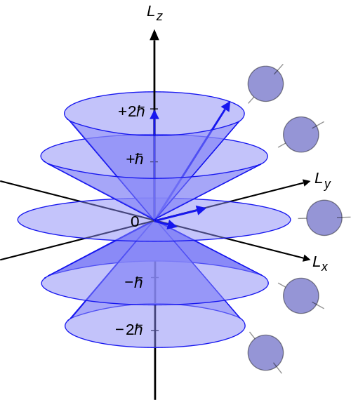
L Vector of Angular Momentum

Angular Momentum has a classical context and a quantum context. The classical definition of angular momentum is L = r × p. The quantum-mechanical counterparts of these objects share the same relationship:
L = r × p where r is the quantum position operator, p is the quantum momentum operator, × is cross product, and L is the orbital angular momentum operator
There is another type of angular momentum, called spin angular momentum (more often shortened to spin), represented by the spin operator S = ( S x , S y , S z ). Spin is often depicted as a particle literally spinning around an axis, but this is only a metaphor: spin is an intrinsic property of a particle, unrelated to motion in space. All elementary particles have a characteristic spin, which is usually nonzero.

- Angular momentum cannot be oriented purely in the z axis

- Spin Angular Momentum: quantum number is from a range of 0, ½, 1, 3/2, 2, 5/2. Bosons (Messenger particles) full integer spin. Fermions have half-integer spin.

- Coupling- 2 or more Angular Momentum interactions with each other so the angular momentum can transfer from one to the other (i.e. spin-orbit coupling) transfer of L to S (orbital to spin). (see below)

- Angular Momentum Rotation: the total AM or J characterizes how a quantum system is changed when it is rotated. R is the Rotation Operator

- Conservation of angular momentum states that J for a closed system, or J for the whole universe, is conserved. However, L and S are not generally conserved. For example, the spin–orbit interaction allows angular momentum to transfer back and forth between L and S, with the total J remaining constant.

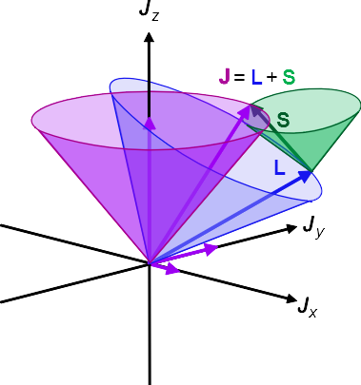
Total angular momentum in Quantum Systems
In quantum mechanics, the angular momentum operator is one of several related operators analogous to classical angular momentum. The angular momentum operator plays a central role in the theory of atomic and molecular physics and other quantum problems involving rotational symmetry. Such an operator is applied to a mathematical representation of the physical state of a system and yields an angular momentum value if the state has a definite value for it. In both classical and quantum mechanical systems, angular momentum (together with linear momentum and energy) is one of the three fundamental properties of motion.
There are several angular momentum operators: total angular momentum (usually denoted J), orbital angular momentum (usually denoted L), and spin angular momentum (spin for short, usually denoted S). The term angular momentum operator can (confusingly) refer to either the total or the orbital angular momentum. Total angular momentum is always conserved, see Noether's theorem.
total angular momentum J = ( J x , J y , J z ), which combines both the spin and orbital angular momentum of a particle or system:
J = L + S
the total angular momentum operator characterizes how a quantum system is changed when it is rotated. The most general and fundamental definition of angular momentum is as the generator of rotations. More specifically, let R ( n, ϕ ) be a rotation operator, which rotates any quantum state about axis n by angle ϕ. As ϕ → 0, the operator R ( n, ϕ ) approaches the identity operator,1, because a rotation of 0° maps all states to themselves. Then the angular momentum operator J is defined as:

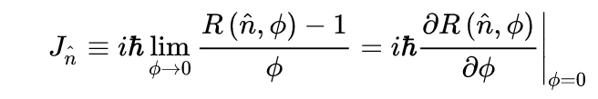
Also notice that R is an additive morphism : R ( n , ϕ 1 + ϕ 2 ) = R ( n , ϕ 1 ) R ( n ^ , ϕ 2 ); as a consequence
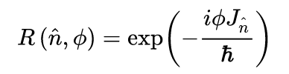
where exp is matrix exponential. And h is Planck’s constant.

Often, two or more sorts of angular momentum interact with each other, so that angular momentum can transfer from one to the other. For example, in spin–orbit coupling, angular momentum can transfer between L and S, but only the total J = L + S is conserved. In another example, in an atom with two electrons, each has its own angular momentum J1 and J2, but only the total J = J1 + J2 is conserved.

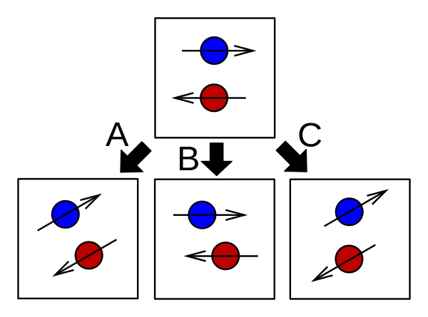

The different types of rotation operators. The top box shows two particles, with spin states indicated schematically by the arrows.
- The operator R, related to J, rotates the entire system.
- The operator Rspatial, related to L, rotates the particle positions without altering their internal spin states.
- The operator Rinternal, related to S, rotates the particles' internal spin states without changing their positions.

Thus, we see from this general overview of Angular Momentum and it’s relationship to Entanglement that spin and orbital angular momentum come into play with the Ahronov-Bohm toroid, or helical coil generator. So that rotation is related to entanglement, meaning that anything in rotation is entangled, also this could mean that a Closed Timelike Curve (EPR=CTC?) can only occur in rotating spaces so if the universe is rotating it is entangled as a whole, which comes into play with what I call the Persinger Time: the actual entanglement velocity, which Persinger puts at 10⁻²³s/m^{-1..} Persinger et al have found that it takes about 8 minutes for the entanglement process to begin in non-local experiments of the A-B Generators, which he also calculated to be equivalent of the Persinger Time to traverse the universe,
This process is based in transition from virtual particle to real particle involving dark energy, ‘entanglement velocity involves the ongoing conversion of dark energy as subthreshold (‘virtual’) photon masses into measurable photon’ (Koren, 2015). Virtual particles of the vacuum fluctuations mediate non-local causality (Persinger, 2015), “a transformation of the state of particles occurs when there is a changing EMF that contributes to or defines a boundary condition, Casimir and A-B effects are at boundary conditions, phase transition is a boundary condition as well. 1 μT increase in Magnetic intensity gives us 2 photon emission at 10⁻¹⁸J (Persinger, 2015)]

Coupling of Electro-Magnetism and Gravity into Gravito-electromagnetics (GEM)

To understand the mechanics further of the A-B Generators it is necessary to review general theories of Electro-Magnetism and the coupling with Gravitoelectromagnetics, as well as a general overview of the Ahronov-Bohm effect and the Casimir Effect, of which for the purposes of biological influence are interrelated as Casimir Effect phenomena are argued to occur in the neurons of the Brain by Persinger et al, Norseen, Badhyapadhyay’s Group.
There is a direct relationship between photons and entanglement. Photons the Messenger Boson (spin 1) of the electro-magnetic spectrum are related to entanglement and the graviton. In a study on the A-B Generators it was found that entanglement reflects both the mass and velocity of the electron-wave (photon) duality” (Koren, 2016, 3337). As the electron and photon represent the duality, a relationship is related to Gravity through it’s particle the graviton and the photon. As explained by Koren:

The ~10²³ m·s⁻¹ value relates the rest mass of the graviton and the rest mass of the photon as intersecting phenomena that may only differ by the proportion of involvement of the entanglement velocity. The product of the upper boundary for the rest mass of a photon (2·10⁻⁵² kg, the velocity of light (3·10⁸ m·s-1 ) and the entanglement velocity (2.8·10²³ m·s-1 ) is 1.7·10⁻²⁰ J. On the other hand the product of the upper boundary of a graviton is ~2·10⁻⁶⁵ kg. In this case the square of the entanglement velocity derived from the electric and magnetic energy equivalents of 0.8·10²³ m·s-1 (that does not involve G) is 4.4·10⁻¹⁹ J. This is within the range of the visible wavelength. Clearly if the actual value was 10⁻ ⁶⁶ kg for the theoretical graviton the energy for the emergent photon and graviton would be potentially convergent. This is another support for the quantitative relationship and perhaps identity between the process labeled as Gravity and that labeled as “light” which persistently exhibits the dual properties of wave and particle.” (Koren, 2016, 3337)

When an electron shifts Bohr shells it discharges 2 photons of spin-1, a photon is composed of gravitons of Spin 2. An electron is spin ½. So we see 3 bands of spin involved in entanglement. The interaction between pohtons and gravity, gravitons identity changes (Spin 2), so it can form the EM properties of photons (spin=1). The electron is a half-concrete (electron) and half virtual particle (photon) as it traverses the Compton Wavelength for the electron orbit.

So this shows us the progression through EM-Light(Photon)-Gravity as we shall see below.

Maxwell Equations for Electro-Magnetism (EM)

Maxwell’s equations as we understand them today were abridged by Heaveside. The original Maxwell equations comprised dozens of equations, which were simplified by Heaveside to the four main equations below. As far as the potential energy vectors of Ahronov-Bohm effect, these equations were first hinted at in the work of Whittaker in 1904, a one-time astrophysics teacher at the Observatory in Dublin, Ireland.
Here I list the Maxwell Equations for reference. These equations are taken from Gravitational Physicist Raymond Chiao of the University of California at Merced, I reference his work below for the Gravitational versions of these equations as well
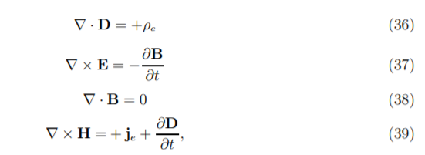
where ρ_{e} is the electrical free charge density (here, the charge density of Cooper pairs), and j_{e} is the electrical current density (due to Cooper pairs), D is the displacement field, E is the electric field, B is the magnetic induction field, and H is the magnetic field intensity.

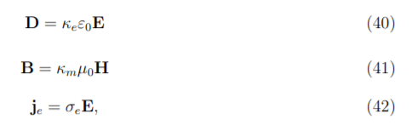
where κ_{e} is the dielectric constant of the medium, κ_{m} is its relative permeability, and σ_{e} is its electrical conductivity (Chiao et al, 2002)

For clarification the field we are mainly interested in is the B (magnetic) Field, which in the quaternion version of the Maxwell Equations of Whittaker is the scalar magnetic Φ usually annotated (A, Φ) for both the scalar part and the vector part.

Ahronov Bohm Effect

In a 1959 paper, Y. Aharonov and D. Bohm contrary to the conclusions of classical mechanics, the electromagnetic 4-potential (A, Φ), the motion of an electron beam, even in regions where the electromagnetic field vanishes can still affect a particle. Ahronov-Bohm takes hold at boundaries and in macrostructures in phase shifts of matter, “Attributing the Aharonov-Bohm effect to the four-potential A is possible only where the EM field vanishes.” (Friedman et al, 2014) The application of the A Vector Potential is based on the work of Whittaker in 1904. As explained by Israeli Mathematician Friedman:

The Aharonov-Bohm effect is traditionally attributed to the affect of the electromagnetic 4-potential A, even in regions where both the electric field E and the magnetic field B are zero. We argue that the quantity measured by AB experiments may be the difference in values of a multiple-valued complex function, which we call a pre-potential [Persinger’s Second Derivative? See below]. The pre-potential is a combination of the two scalar potential functions introduced by E. T. Whittaker. We show that any electromagnetic field can be described by such pre-potential, and give an explicit expression for the electromagnetic field tensor through this potential. (Friedman et al, 2014)

Another important understanding to have of the A Vector is that it is applicable to quantum physics not classical physics as indicated by Waechter:

In contrast to classical mechanics, where the equation(s) of motion contain only the electric and magnetic field, in quantum mechanics the Schrödinger equation explicitly contains the electromagnetic potentials. This fact was known since the beginning of quantum mechanics, but it wasn’t until the publishing of the paper Significance of Electromagnetic Potentials in the Quantum Theory [7] by Y. Aharonov and D. Bohm in 1959, that the consequences of this fact received serious attention. (Waechter, 2018)

An electromagnetic four-potential is a relativistic vector function from which the electromagnetic field can be derived. It combines both an electric scalar potential and a magnetic vector potential into a single four-vector.
As measured in a given frame of reference, and for a given gauge, the first component of the electromagnetic four-potential is conventionally taken to be the electric scalar potential, and the other three components make up the magnetic vector potential. While both the scalar and vector potential depend upon the frame, the electromagnetic four-potential is Lorentz covariant.
Like other potentials, many different electromagnetic four-potentials correspond to the same electromagnetic field, depending upon the choice of gauge.
The magnetic vector potential A is a vector field, defined along with the electric potential ϕ (a scalar field) by the equations:
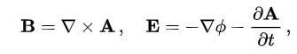
where B is the magnetic field and E is the electric field.

The A-B Effect involves using potential energies at boundaries of EM Fields where the field disappears but not potential energies or what I would call information. In the toroidal and solenoid experiments with A-B Generators of Persinger’s Group they work changing phase shifts:

The phase shift of the Aharanov-Bohm effect can be described as:
Δθ=qVt ħ⁻¹ (1),
where q is the unit charge, V is the voltage, t is the time or duration within the voltage field and ħ is the modified Planck’s constant.” (Koren, 2016)
More specifically the involvement of an Aharanov-Bohm effect indicates that for phase-modulation or phase shift to occur the average change in voltage must be near the peaks of capacity but not at the peaks of capacity. Consequently forcing the systems to its limits or maximum boundaries (-5 to +5 V), in addition to distorting the signal, would be above the narrow band pass. This has been observed in our systems. Values below the value would not be sufficient to elicit the effect. Because our signals are constructed from a series of numbers (integers) ranging from 0 through 256 (-5 to +5 V) and pass through the critical zone, perhaps the efficacy of our patterns might be re-evaluated with respect to what proportion of “time” or passes occur within the 4.1 to 4.3 V band. This could be considered a metaphor for the duration within the voltage field.” (Koren, 2016)

.

Gravitational Maxwell Equations

The Soviet researchers learned that there is a conversion between Electromagnetic Waves and Gravitational Waves. Which explains the Soviets focus on Gravitational Wave based non-local cybernetic experiments as early as 1967 (McCarron, 2021, Ch. 6 ‘Physics of Neuroweapons’). A Russian researcher, V. Samokhvalov, continuing on the earlier Soviet research in this area, explains the subtle energies which could be overlooked, he comments:

According to Einstein’s general theory of relativity, the rotating mass field differs from non-rotating mass field by additional, so-called, gravimagnetic forces , which affect rotating objects . Taking this fact into consideration, it is assumed that gravimagnetic forces act only if they are close to large masses or in presence of masses moving at relativistic speed, and they do not exhibit themselves in nature because of their extremely small values. However, many researchers in their works mentioned facts, which showed significant non-electromagnetic interaction of small objects, rotating at low speeds, with each other and with the objects, surrounding them.

One of the first evidences of such kind was the experiments of Professor N.P. Myshkin, which were carried out at the beginning of the XX century. The effect of change in weight of rotating objects (gyroscopes) and their non-electromagnetic interaction with other objects are described in works by N.A. Kozyrev, V.V. Roshin and S.M. Godin, S.V. Plotnikov, etc. The experimental research...also showed that in nature there is a significant value contactless interaction of rotating small masses and their force effect on closely located objects (masses) at relatively small rotary and linear speeds of rotation. The value of occurring mass-dynamic forces is by 20 orders more than the value of gravimagnetic forces, which act in this case according to general theory of relativity.[see Persinger observation of 20x greater entanglement reactions in his experiments of non-local entanglement]

Experimentally determined non-electromagnetic interaction was called mass-dynamic interaction, because it is determined by dynamic mass rotation, having a variable quadrupole [see Einstein’s Gravitational Quadropole equation below] moment. The research, which was carried out, showed non-electromagnetic nature of force interaction, i.e. independence of interaction force effects from electrical conductivity of disc materials and dependence of force interaction value on their rotation frequency.
(Samokhvalov, 2016)

The deniers of the scientific reality of this technology, which seems to be an information operation aimed at keeping state-secrets secret, have claimed that this is an EM conductive or thermal effect, this is not what the researchers are claiming, they are claiming that there is a potential EM non-thermal effect, A-B Effect, and that is the basis of the A-B Generators. This is also related to the argument against Thought-Injection or QSK that the magnitudes, here talking about magnetic fields of 1-5μT, are too small in terms of electric conduction, which we see below is not based on experimental findings. .

There is another A-B Effect that is not EM based. The equivalent in Gravitational Theory, according to many researchers, including R. Chiao, the gravitational equivalent of the Gravitational Ahronov-Bohm effect. So that one does not as seen need to use Electric force in entanglement experiments but rather potentials can accomplish what force can. Chiao has written of the conversion from Maxwell Equations to Gravitomagnetic Maxwell Equations.

“The gravitoelectric field E_{G}, which is identical to the local acceleration due to gravity g, is analogous to the electric field E, and the gravitomagnetic field B_{G}, which is identical to the Lense-Thirring field (Poynting Vector of Magnetic flux), is analogous to the magnetic field B; they are related to the vector potential h in the radiation gauge as follows:
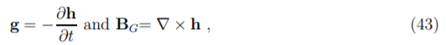
which correspond to the electromagnetic relations in the radiation gauge
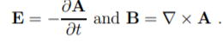
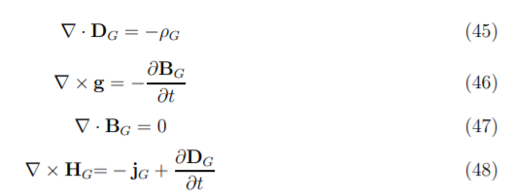
(Chiao et al, 2002)

where ρG is the density of local rest mass in the local rest frame of the matter, and j_{G} is the local rest-mass current density in this frame (in the case of classical matter, j_{G} = ρGv, where v is the coordinate three-velocity of the local rest mass; in the quantum case). Here H_{G} is the gravitomagnetic field intensity, and D_{G} is the gravitodisplacement field. Since the forms of these equations are identical to those of Maxwell’s equations, the same boundary conditions follow from them, and therefore the same solutions for electromagnetic problems carry over formally to the gravitational ones.” (Chiao et al, 2002)

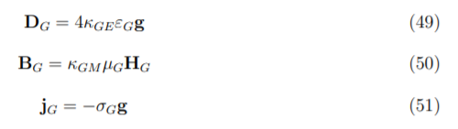
where εG is the gravitoelectric permittivity of free space given by Eq. (35), µG is the gravitomagnetic permeability of free space given by Eq. (32), κGE is the gravitoelectric dielectric constant of a medium, κ_{GM} is its gravitomagnetic relative permeability, and σG is the gravitational analog of the electrical conductivity of the medium, whose magnitude is inversely proportional to its viscosity (Chiao, 2002)

Viscosity and brain structure are reviewed in McCarron 2021 Ch. 8

So it is important to understand there is a gravitational correlate to EM, as shall be pointed out later these potentials exist not in classical scale but quantum scale. It is worthwhile to point out there is a high frequency gravitational wave based equivalent to this type of remote sensing as adapted see Baker-Li HFGW Military Applications in McCarron 2021 Ch. 6 ‘Physics of Neuroweapons’.

Einstein’s Quadropole Equation:
To measure the strength of a Gravitational Wave due to the change of masses the following equations were formulated.

Because of symmetry, the quadropole moment (of Einstein’s quadropole-approximation equation) can be related to a principal moment of inertia, I, of a mass system and can be approximated by
In which -dE/dt is the generated power output of the GW source, P is in watts, c is the
speed of light, G is the universal constant of gravitation, and d³I/dt³ is the third time
derivative of the moment of inertia of the mass system. The GW power is usually quite
small because of the small coefficient multiplier. (Baker, 2010, 20)

The GW frequency is 2ω or twice the orbital frequency ω. That is, for ever period of an electron the graviton is 2x, twice the frequency of the electron. Following for a one-meter long rod spun so fast as to nearly break apart due to centrifugal force, the radiated GW power is only 10⁻³⁷ watts.

See below for R. Chiao et al treatment of Einstein’s GW Quadropole equation by modifying it.

One sign that there may be a Gravitational component to the A-B generators is that Kernbach (2017) noticed that energy collected near the tip of the A-B Generator cone. This axial radiation in the z-coordinate (tip point direction) could be explained in that GW radiation is concentrated in the angular portion of rotation, near the axis, which suggests the ability to emit the GW with directionality.

Gravitational Ahronov-Bohm Effect
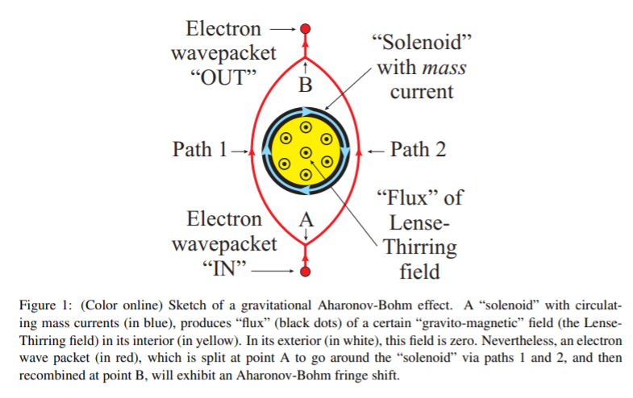
As mentioned above there is based on gravito-electromagnetics (GEM) also a gravitational Ahronov-Bohm effect. R. Chiao explains that:

“...mass currents in a cylindrical superconducting (SC) mass shell (indicated in black in Figure 1), could be produced by rotating the shell at a constant angular frequency around its cylindrical axis. The two partial waves could then be recombined into an outgoing single-electron wavepacket at point B by means of another beam splitter. Just like in the purely electromagnetic AB effect, the “flux” of a certain gravito-magnetic field (i.e., the Lense-Thirring field) would be confined entirely to the interior region (indicated in yellow in Figure 1) of the “solenoid,” and would vanish at all points in its exterior (indicated in white). There results a quantum mechanical AB fringe shift due to the “flux” that is observable at point B, which cannot be explained classically” (Chiao, 2013)

Bg is the Lense-Thirring Field or the magnetic flux in the interior of the solenoid pictured above. Which is an analog to the solenoids used in Persingers non-local experiments till 2015. However, the real difference here is the Angular Momentum as explained:

“...if one thinks of the “solenoid” as a rotating SC [super conductor] cylindrical mass shell, the experiment has two independent parameters, namely, the linear mass density, and the angular velocity of the shell. That means one could shift the interference fringes by changing the angular velocity. Since the gravitoelectric field from the mass of the shell does not depend on the angular velocity, a fringe shift will happen despite the fact that the classical force has not changed. Hence the AB fringe shift in the gravitational case could not have had a classical origin.” (Chiao, 2013)

In an analog to the EM Maxwell equations the A vector potential is equivalent to magnetic field B. In gravitational theory, h is the magnetic like gravitational vector potential, so you can think of h is like A. Vector Potential (h) can arise either from a Lense-Thirring field, or from rotations of a quantum system, such as from a rotating SC ring (solenoid, toroid). Expriment with rotating SC rings are easier to perform then those with Lense-Thirring fields. Phase shift occurs in this experimental setup, “The phase shift , which is nonvanishing for the “solenoid” configuration of Figure 1, is the gravitational AB phase shift. It is closely related to Berry’s phase, since both phases have a common origin in non-Euclidean geometry” (Chiao, 2013, 6).

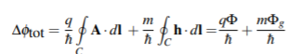
In eq. 33 (Chiao, 2013), these quantum currents can be the quantum mechanical sources of time-independent A and h fields that give rise to the AB effect. (Chiao, 2013, 7).

Chiao further speculated that a gravitational version of “pumping gravitons out of the vacuum” via parametric amplification, and above threshold, parametric oscillation, might be possible. The analog of a laser for gravitational waves could thus be constructed.

Casimir Effect, Gravitation and Entanglement
The vacuum oscillations/fluctuations or what others refer to as the Zero Point Energy field (ZPE) (Norseen, 2002) is interfaced with the Casimir Effect. Scientists have directly related entanglement with the Dynamic Casimir effect of which accelerating modulation or ‘jerks’ are an example (Romauldo, 2019) as we shall read further later. Romauldo et al found that Casimir effect produces a high degree of entanglement, and study that process. Felicetti et al study the Dynamical Casimir Effect in it’s relation to creating entanglement in bipartite and multipartite entanglement among qubits.

“The existence of vacuum fluctuations, i.e., the presence of virtual particles in empty space, represents one of the most distinctive results of quantum mechanics. It is also known, under the name of dynamical Casimir effect, that fast-oscillating boundary conditions can generate real excitations out of the vacuum fluctuations. Long-awaited, the first experimental demonstration of this phenomenon has been realized only recently, in the framework of superconducting circuits [C. M. Wilson et al. Nature 479, 376-379 (2011)].” (Felicetti, 2013)

For our purposes the Dynamical Casimir Effect (DCE) is of interest as this is the corollary to the work involved with the A-B generators, the pulsating modulation of magnetic amplitudes, which is what a DCE is an equivalent of a generation of photons from vacuum due to the motion of uncharged boundaries.
Raymond Chiao of University of California-Merced has proposed the concept of a gravitational laser based on the DCE which we can use to see how pulsations are conducted in the EM version of our toroidal coil, the A-B Generators. (Chiao, 2017). Many would consider gravitational amplitudes to be so minute that it could never be possible to generate or detect based on their understandings of Einstein’s [Quadropole] equations for Gravity. However, Chia introduces a Planck scale mechanism which argues for the ability to generate and detect gravitational effects in the laboratory. He introduces the ideal of “relative gravitational permeativity” which is analogous to EM electric permittivity and magnetic permeability, hence ‘permeativity’, as G is stands in for E and M. Permeativity, argues Chiao, allows for a possibly large quantum mechanical enhancement of the response of a superconductor, such as the solenoid or coil, to an incident tensor gravitational wave field.” (Chiao, 2017) The group has also argued that the quantum amplification process in the DCE is equivalent to the amplification process in a parametric amplifier (paramp). Chiao et al point out that in Einstein’s quadropole equations, used for figuring Gravitation, that the Planck Constant, the quantum of electromagnetic action that relates a photon’s energy to it’s frequency ( h= 6.62607015×10⁻³⁴ J⋅s in SI units ), is absent which he modifies to include, placing the equations in a quantum level of existence rather then classical scale. Meaning that Gravitational Waves on the quantum scale (Planck Length 10⁻³³ cm) has greater force then anticipated by the Classical gravitational force. This directly addresses the issues of the assumption by many scientists that none of this is possible due to the low Lorentz forces involved in Electromagnetic force. This is addressed by Dotta when studying Long Term Potentiation in neural networks:

“The primary effect upon the shift of the spectra power density of the photon emissions following the modified LTP magnetic field exposure suggests that the temporal geometry of the applied field interacts with the temporal pattern of the photon emissions. Pattern is often associated with information and does not require significant addition or subtraction of energy from the system. As succinctly summarized by Cifra et al. [13], a shift in the rate of temporal patterns by which energy is emitted rather than induced by the applied magnetic fields minimizes the counterargument that their intensities are too small to overcome the kT values associated with intrinsic thermal oscillations “ (Dotta et al, 2014)

It is an important point to understand this when faced with criticisms regarding the lack of sufficient strength from the A Potential Vector and it’s GEM analog. This question of low amplitudes affecting biological objects was also addressed by Djumeava in her studies on using A-B effect to transmit medicines remotely:

In the recent decade, low level laser (LLL) therapy has been used to treat various diseases. The question about how the energy from low level lasers works at the cellular and organism levels is still disputable. In 1977 A.C.Tam and W.Happer showed experimentally that two circularly-polarized laser beams attract or repel depending on mutual orientation of their circular polarization. If the direction of rotation of polarization of the two laser beams is similar, then these beams attract, and if the rotation of polarization is opposite, then they repel. These results collided with quantum electrodynamics and could not be explained. Study conducted by A. Bobrov demonstrated the presence of non- electromagnetic component of laser beam which doesn’t shield by electromagnetic screen and spreads in the direction of laser beam’s distribution. In 2012 M.Krinker showed a bio-physical similarity between spinning fields and information imprinted in special carriers. According to the data obtained by the authors of Russian patent, when the spiral light-guide is twisted from the right to the left, the effect of strengthening mitosis in the cells exposed to the non-electromagnetic properties of laser radiation was observed, whereas the light-guide spiral twisting from the left to the right leads to strengthening of synthesis of protein and carbohydrates. In M. Krinker ‘s experiments a maximal growth of cell took place in case when they were exposed to the counterclockwise field. In our case we also utilized the device with the counterclockwise light-guide. (Djumeava, 2004)

It is argued by Persinger that the Minkowski space becomes one space through the irrelevance of time (t):

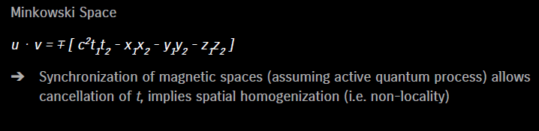
(Persinger Group Presentation at 2016 The Science of Consciousness Conference, organized by Stuart Hameroff)

In other words through entanglement time becomes irrelevant and locality also become irrelevant with the ability to have separate space interact through entanglement.

Analysis of the A-B Generator Poynting Vector

“This experiment, based upon physical principle, suggests there is a technology that can generate reliable excess correlation of brain activity (and potentially consciousness and specific experiences) between two [or more] people separated by thousands of kilometers.” (Scott, 2015)

The A-B Generators use what is known as a Poynting Vector in EM engineering to accomplish it’s transmission of potential energies to a receiver or target. Dr. Serge Kernbach has studied the A-B Effect Poynting Vector Emmitter (PVC) in terms of non-local interactions between an emitter and a receiver or target, he reconstructed the generator built by Akhimov and conducted measurements in experiments to understand the phenomenon.

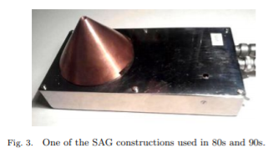

The Poynting Vector can be inferred to discern the direction the energy is moving within space-time: S=M₆⁻¹[VxM⁻¹]xB μtheta = 4pi x 10⁻⁷ (Kernbach, 2017). Poynting vector (S = E x H) represents the directional energy flux (the energy transfer per unit area per unit time) of an electromagnetic field. The SI unit of the Poynting vector is the watt per square metre (W/m2). It is named after its discoverer John Henry Poynting who first derived it in 1884. Oliver Heaviside also discovered it independently in the more general form that recognizes the freedom of adding the curl of an arbitrary vector field to the definition. The Poynting vector is used throughout electromagnetics in conjunction with Poynting's theorem, the continuity equation expressing conservation of electromagnetic energy, to calculate the power flow in electric and magnetic fields.
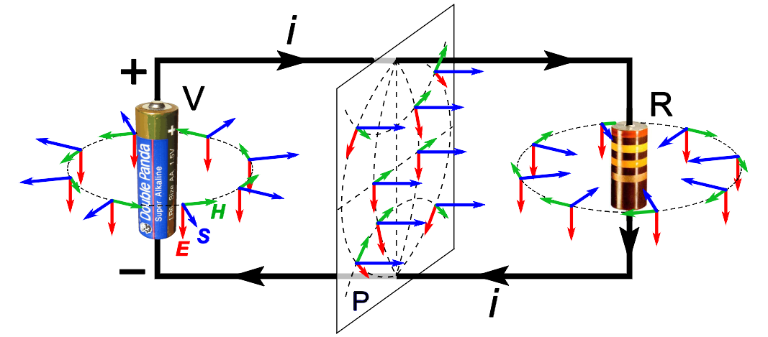
A DC circuit consisting of a battery (V) and resistor (R), showing the direction of the Poynting vector (S, blue arrows) in the space surrounding it, along with the fields it is derived from; the electric field (E, red arrows) and the magnetic field (H, green arrows). In the region around the battery the Poynting vector is directed outward, indicating power flowing out of the battery into the fields; in the region around the resistor the vector is directed inward, indicating field power flowing into the resistor. Across any plane P between the battery and resistor, the Poynting flux is in the direction of the resistor. The magnitudes (lengths) of the vectors are not shown accurately; only the directions are significant.

There are 2 types of EM oscillation: harmonic- E/H vary according to sine and cosine law. Modulated- amplitudes frequency or phase vary according to a law. In the case of the toroid coil system we are dealing with a modulated amplitude frequency device. A-B Generators use orthogonal ExH fields to generate Poynting Vector (S) which is rotating due to shielding only the torsion [AB effect] component is emitted out through the copper cone” (Kernbach, 2017). The Poynting vector is a planar wave sent out in the x-axis.

Kernbach points out the relationship of angular momentum and force created by the generator:

“Although only static electric and magnetic fields exist, the calculation of the Poynting Vector gives a circular flow of EM energy clockwise [coil is wound cw, Persinger is ccw] The flow of circulating energy underlies the popular idea of ‘rotation’ of the S (Poynting) vector which is located in the axial plane (the circulating energy flow contains the angular momentum and creates the magnetic component of the Lorentz force arising when the capacitor is discharged.” (Kernbach, 2017)

The generators studied by Sokolova (2016), who worked with this technology from at least 1982, have 3 modes of operation:
- negative (turns ordered field into a completely disordered distribution of curves, the curves are preserved;
- a positive transition;
- The zero channel or neutral is the channel that carries information with very low force and energy, the ‘psi’ channel. It should be noted that Russian researchers such as Sokolova cite the gyromagnetic ‘spin-wave’, as well as the A-B effect in these generators.

An gyromagnetic effect arising from the relation between the angular momentum and the magnetization of a magnetic substance. It is the effect which is exploited in the measurement of the gyromagnetic ratio of magnetic materials. The gyromagnetic effect is demonstrated by a simple experiment in which a freely suspended magnetic substance is subjected to a magnetic field. Upon a change in direction of the magnetic field, the magnetization of the substance must change. In order for this to happen, the atoms must change their angular momentum. Since there are no external torques acting on the system, the total angular momentum must remain constant. Thus the sample must acquire a mass rotation which may be measured. In this way, the gyromagnetic ratio may be determined. Two common methods of determination are the Einstein-de Haas method and the Barnett method. (Abrahams et al, 2019)

Synchronization of emitters and receivers
Researchers have noticed that non-local transmitters and receivers have synchrony, develop the same rhythmic patterns, though driven at different times by local forces. One of the phenomena observed in use of these generators by both Kernbach and Persinger is the synchronization of the emitters in Kernbach’s case the Akimov Generator in Persinger’s the use of a circular solenoid and a circular toroid. Kernbach remarks “It is assumed, as a working hypothesis, that the well-known synchronization effect of coupled oscillators with weak (nonlocal) coupling plays here a key role.” (Kernbach, 2017, 37) He further points to entanglement as the reason for the synchronization, “synchronize emitters and receivers. Here an analogy with the well known phenomenon of quantum entanglement is assumed. The long range spin-spin interactions are well established research topic.” (Kernbach, 2017) Here he directly mentions the spin theories of Akimov which we know to be the normative physics concept of angular momentum. Another issue related to synchronization was the uptick in responses in detection of AB potentials in sensors when using a desynchronized rhythm, “increasing reaction of sensors was accomplished when frequency desynchronizing between 2 generators increase sensor response.” Like Persigner, Kernbach also like found that there is a connection to 7 to 8 min gap between initiation of the field and onset of ‘entanglement’ like activities, Kernbach remarks “there is a 7-8 min delay between emitter turned on and reaction through proton tunneling.” (Kernbach, 2017). Here Kernbach like Persinger find a connection to proton tunneling, which in biochemical terms would be the Ca⁺ ion mentioned by Norseen for neurological reactions, membrane channels for positively charged ions.

A further example of an Ahronov-Bohm Generator was that designed by American physicist Hal Puthoff, a former researcher at Stanford Research Institute, where also early Remote Viewing experiments were conducted, such as with Ingo Swann who was tested by Persinger, and the basis of the experiment that led to the conclusion of Persinger that remote viewing could be blocked (Persinger, 2002). This generator is different from the Akimov generator in that it uses angled shields for changing the angular components controlling frequency of the signal. Puthoff defines this invention as, “A method of transmitting information that changes as a function of time comprising transmitting a signal having scalar and vector potentials (A, phi) without including an EMF, the signal varying as a function of time in accordance with the information. (Puthoff, 1998)

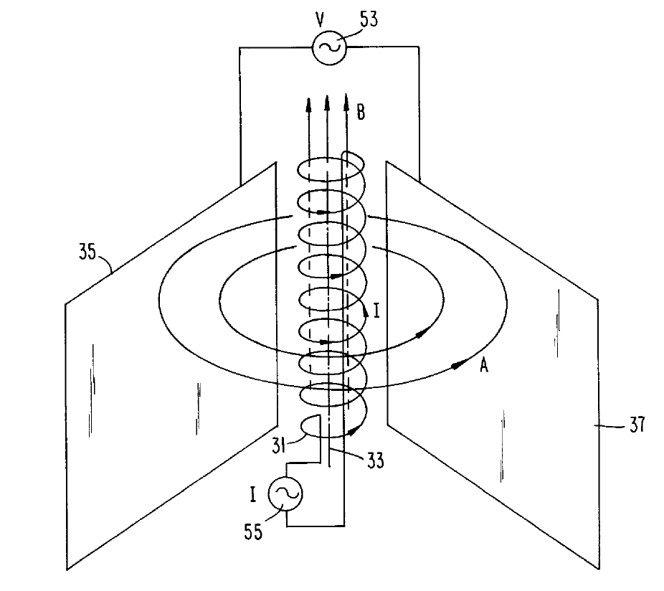
(Puthoff, 1998)

As can be seen here the coil used in this system does not have a larger base and then condense as it coils in the z axis, this coil has a constant width, which is also used in another version of the generator according to Puthoff where he uses two toroid coils (patent item #85,87), these coils are the equivalent of the system used by Persinger et al from 2015. Puthoff instructs on how the coils work, “A-B generator coils #85,87 are driven in parallel by current source, currents are time-derivative phased and adjusted in amplitude to provide a time varying (A,phi) signal [potentials] having no EM component in the same planes as (A, phi) signal radiates.” (Puthoff, 1998) Persinger in his work with these coils has defined based on Tu (2005) phase and group velocities that he describes as:

group velocity- bulk movement of the field around the circle (coil or solenoid array)
phase velocity- temporal configuration (rhythm) irregular frequency shifting pattern with in the bulk movement.

Which we can see correspond to that which is mentioned by Puthoff. The key ingredient here is that there is no EM Field in the plane of the transmitted signal comprised of potentials.
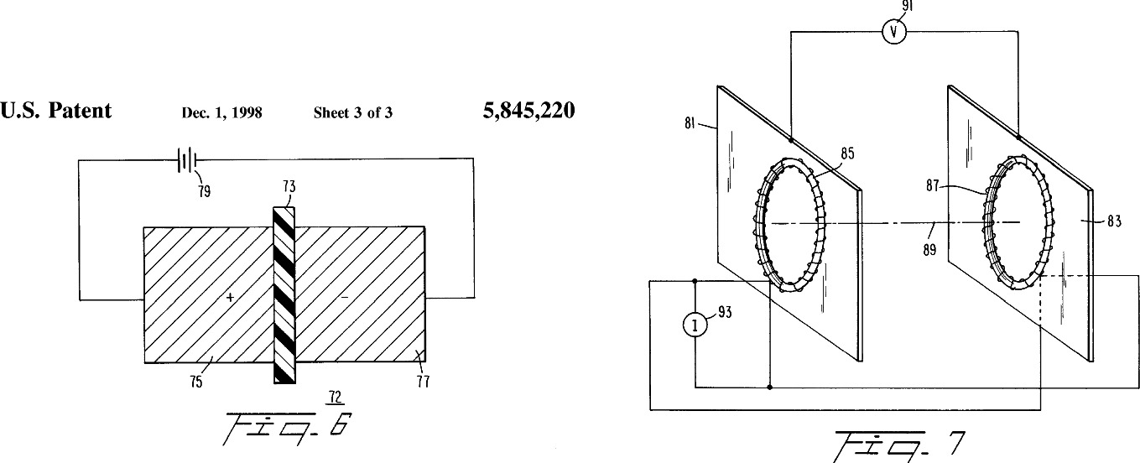

The coils are time derivative (phase velocity) phased and adjusted in amplitude (group velocity) providing a time varying (A, phi) signal having no EM component in the same planes [horizontal, Y coordinate] as the (A, phi) signal radiates. In the countermeasure we are using just one of the coils since we have no need for entanglement with another since it encompasses one object (see Lehman, 2015). The toroid coils are able to induce changes in interference patterns as explained by Puthoff, “it is shown that in certain two-leg electron-interferometer configurations in which the potentials (A,phi) are establish in a regional space, but E and B are absent, it is still possible for the potentials to induce changes in electron quantum interference patterns.” (Puthoff, 1998)

As one examines the coil, it is clear that what we are looking at is really a helical structure as the wire wraps around the hoop it creates an analogous DNA helix around the circle. The use of a helical structure is also performed in the HFGW detector/transmitter of Baker-Li (Baker, 2010).

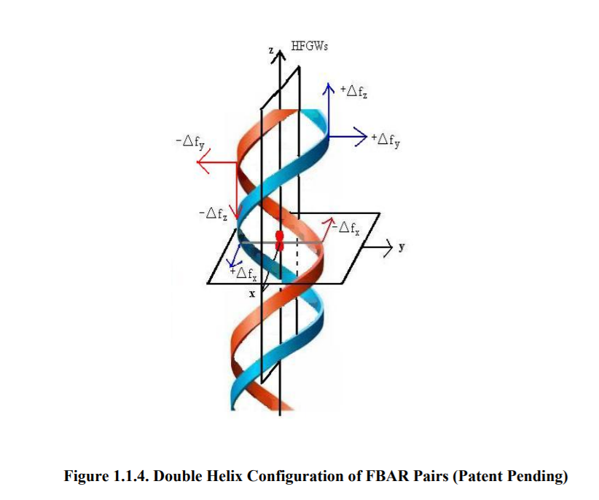
In this case he is citing the use of FBARs which are already miniaturized in mobile phones, which is used to detect gravitational waves according to Baker. Persinger remarks how this relates to entanglement angular momentum “[Graviton] the involvement of an (closed) circular geometry moving in an direction (a helix) around an infinite but bounded perimeter is important single photon with helical phase structures could carry a quantized amount of orbital angular momentum.” (Persinger, 2013).

According to Baker the Poynting Vector is the x-axis and propogates in both directions. His Gravitatonal Wave Poynting Vector is known as perturbative photon flux (PPF), (Baker, 2010, 29). HFGW are directed along the z-axis.

The perturbative photon flux (PPF), which signals the detection of a passing
gravitational wave (GW), is generated when the two waves (EM and GW) have
the same frequency, direction and phase. This situation is termed “synchroresonance.”
These PPF detection photons are generated (in the presence of a
magnetic field) as the EM wave propagates along its z-axis path, which is also the
path of the GWs,
2. The magnetic field is in the x-direction. According to the Li effect, the PPF
detection photon flux (also called the “Poynting Vector”) moves out along the x axis
in both directions.
3. The signal (the PPF) and the noise, or background photon flux (BPF) from the
Gaussian beam have very different physical behaviors. The BPF (background
noise photons) are from the synchro-resonant EM Gaussian beam and move in the
z-direction, whereas the PPF (signal photons) move out in the x-direction along
the x-axis.. (Baker, 2010, 29)

Dr. Baker and his team at GravWave LLC have also developed an interest in gravitational waves and the human brain hoping to use understanding from gravitation brain (Bar, 2007) for exobiological detection of life, as well as the direct brain-to-brain transfer capabilities as a communication device. Their work is at exobiologie.com. This work is based on the theories of Israeli physicist, Daniel Bar, of Bar Ilan University who came up with the insight that gravitational brain waves as quantum fluctuations and stochastic quantization, viewing the brain as an EM structure that is also capable of detecting and transmitting GW.

That is, one may physically and logically assume that just as these ionic currents and charges in the brain give rise to electric waves so the masses related to these ions and charges should give rise, according to the Einstein’s field equations, to weak GW’s. From this we have proceeded to calculate the correlation among an n brain ensemble in the sense of finding them at some time radiating a similar gravitational waves if they were found at an earlier time radiating other GW’s. We have used as a specific example of gravitational wave the cylindrical one which have been investigated in a thorough and intensive way… (Bar, 2007)

Detractors again point out that these GW would be to small to be of biological significance, to which Chiao has addressed the scale issue not being the classical Quadropole Gravity equations but a quantum gravitational equation with the addition of permeativity on the Planck scale.

Baker-Woods endeavor to use gravitational brainwaves to search for extraterrestrial life. exobiologie.org/

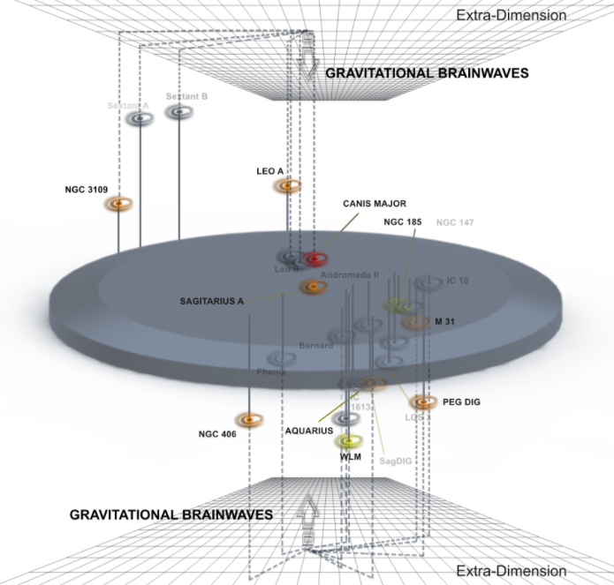
\
The Dark Side of the Poynting Vector

In a follow up study of Kernbach’s in 2018 he replicated the experiments of Akimov done in the Soviet Union in 1986 dealing with the remote influence of biological objects. In these experiments Kernbach looked at how to monitor a remote biological object. He points out that in the experimental setup used that it is possible to use the setup for monitoring via remote non-local technology the object. Kernbach remarks on this reality, “An unexpected result of this replication experiment represents the potential possibility for a remote monitoring of biological organisms (and possibly non-biological objects). By introducing nonlocal feedback, the object on the transmitter side becomes ‘entangled’ with the receiver and can thus become non-locally monitored.” (Kernbach, 2018, 46). He was able to base his understandings with the Z-score in the spectroscopy aspect of the experiment on the documentation provided by Akhimov in the original 1986 experiment. Through the Z-score monitoring is accomplished: “The statistical Z score was calculated based on the EIS [electrochemichal impedance spectroscopy] dynamics of this channel. Thus, the nonlocal address mark was involved in the feedback loop [allows remote monitoring], both in terms of impact and measurement’. (Kernbach, 2018, 43).

One further issue noted by Kernbach was the use of Akimov of such ideals as universal addressing of entangled objects, “Akimov vague allusion ‘special spin (torsion) address matrices’ (Kernbach, 2018). Kernbach has written of mapping entangled objects so it is not out of the question that it may be possible to have a matrix of entanglement that could potentially be searched and indexed via AB Effect type technology that Kernbach has claimed the Soviet Union was interested in for use in mass control.

Other efforts at using A-B Effect technology in Russia is the use of a method known as ‘torsion phase portrait’ (TPP) торсионного фазового портрета (ТФП)) for remote fine field diagnostics. Shkatov in 2009 speaks of the automation of TPP, “the TPP method and its extensions are continuously developing both in instrumental and methodological aspects. It is planned to develop an automated software hardware complex for unmanned periodic TPP a kind of TPP object monitoring.” (Shkatov, 2009)

Skin as Input System to the Brain
Another interesting concept in remote monitoring is that of the Israeli team Feldman et al (2009) which has proposed remote sensing based on the helical and aqueous nature of sweat ducts for monitoring:

The simulation and experimental results are in a good agreement and both demonstrate that sweat ducts in the skin could indeed behave as low Q antennas. Thus, the skin spectral response in the sub-Terahertz region is governed by the level of activity of the perspiration system and shows the minimum of reflectivity at some frequencies in the frequency band of 75-110 GHz. It is also correlated to physiological stress as manifested by the pulse rate and the systolic blood pressure. As such, it has the potential to become the underlying principle for remote sensing of the physiological parameters and the mental state of the examined subject. (Feldman, 2009) [emphasis added]

Again this was a research area originally broached by the Soviet Union then exported to the west like UKUSA and Israel. The use of skin sensing for remote monitoring is of interest as another example of natural toroids within the human body, such as DNA, MTs, etc Sweat ducts are helical conductive tube structure – homochirality (90% right handed turning direction) which is a dipole antenna like the human eye. Skin is the largest organ of the body, designed as the primary interface, utilizing numerous of interactions between us and our environment. The low Q duct antenna which is a 2D antenna array with sub-THz (e.g. 110GHz) range with electrical conductance in the Extreme High Frequency (EHF) range. There is fast proton hopping though distributed H-bond networks along the duct surface, with a time for transport of 10⁻¹³ sec. Difference in pH between skin surface and dermis creates a concentration gradient which is a cause of fast current in the duct coil. There are questions that do come up with remote monitoring through the skin, as well as any light based system of monitoring such as optogenetics, and that is the question of skin tone. AI has proven to have difficulty with darker skin colors, biology and light based technologies as well as the sun itself affect different skin tones differently. The difference is in radiation absorption. There is a case of those with Ephelides (Freckles) like 20% of Ireland, Scotland and Wales who have a different melanin composition from most people, where the melanin is usually eumalanin, for darker colors, those with red/brownish hair and freckles have a different form of melanin, pheomelanin, arising with the MC1R, IRF4, BNC2, OCA2 gene adaptation which gives red hair and rust colored freckles, though it offers no UV protection, it is also different in that it contains Sulfur, hence easy burning of Irish, Scots and Welsh where up to 50% of the population carry at least one of these gene markers for pheomelanin, it also allows very little absorption of UV-A, and other emissions, such as X-Rays which are used for behavioral control of neurons (Yamashita et al, 2021) . Those with eumelanin have an increased absorption of UV and visible light spectrum, eumelanin has increased absorption due to higher molecular weight (Ou-Yang et al, 2004).

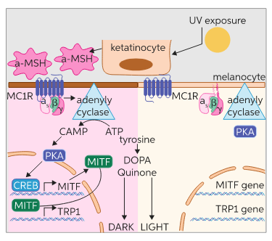
https://www.chegg.com/learn/biology/introduction-to-biology/mc1r-gene
two different pathways between dark eumelanin and light pheomelanin

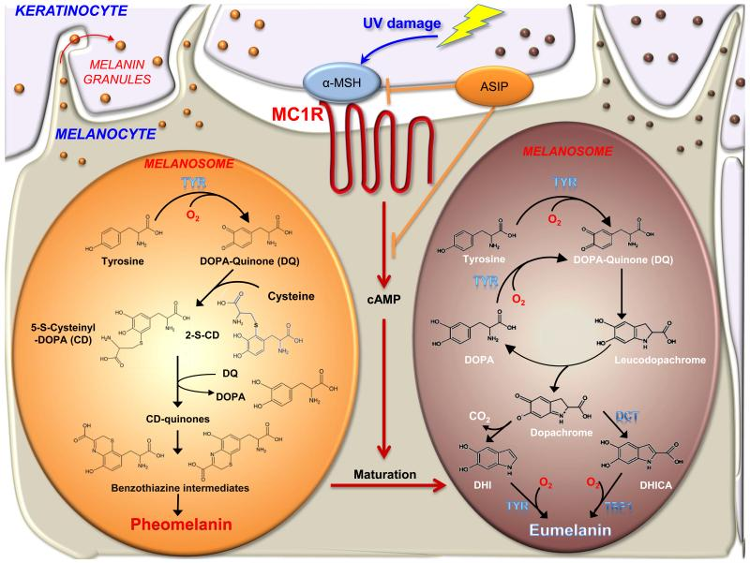
https://www.ncbi.nlm.nih.gov/pmc/articles/PMC4299862/

Do to this difference there are two separate pathways for absorption of EM through the skin as Ou-Yang explains: “Finally, the photostability of pheomelanin is different from that of eumelanin. Both absorption mechanisms tend to drop following UV-A exposure for pheomelanin. We therefore suggest that eumelanin and pheomelanin could be differentiated according to their spectral responses to UVA irradiation.” (Ou-Yang, 2004)

One important note regarding the generation of melanogenesis and melanosome production from melanocortin (POOMC) then alpha MSH and ACTH, ACTh is part of the Hypothalamic pituitary-adrenal axis, produced in response to biological stress. The hypothalamus is noted as a key ingredient to Havana Syndrome like effects as noted by researchers such as Persinger. One obscure connection was the use by Nazi Scientists to use adrenalin to change the Iris color during their experiments with victims of the Holocaust. It is noted that the iris and choroid contain melanin, and also pheomelanin and eumalanin play a role in the eyes.
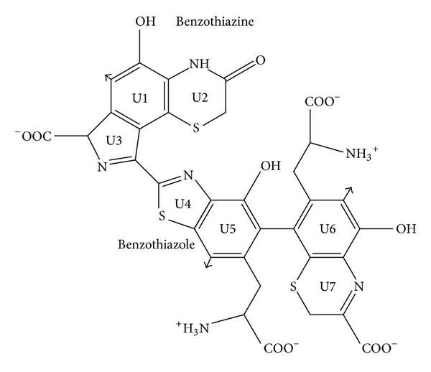
Pheomelanin Chemical Composition (note Sulfur)

A new material has been created by swapping out sulfur in Pheomelanin for selenium (Cao et al 2020) which can be used to block x-rays among other properties.

Further research by Shan et al (2021) has shown in Low Level Light Therapy that the human skin can be affected by the LED version of the Ahronov-Bohm entanglement based attack, they have shown that skin reception of pulsed light can affect 14Hz Brain entrainment by pulsating photons of coherent and incoherent streams, but always pulsed or phase shifted through the skin of the palms:

“In this experiment, the average PSD of the subjects in the parietal and temporal cortex
locations during session 3 was increased and shifted toward lower frequencies in comparison with the rest stage… phenomenon was caused by LED stimulation which was operated at 10 Hz. The normalized alpha activity rapidly increased during and after LED stimulation in the LED group... The affected regions were the occipital, parietal, and temporal regions. LED stimulation exerted a latent effect on alpha rhythm. The effect could persist for at least 15 minutes after LED ceased. Based on the experimental results, LED stimulation at the palm has an effect to induce alpha rhythm activity, and the affected regions were distributed in posterior. The influence was like AVS [audio visual stimulation], but the latent time was longer. In the control group, no significant variation in alpha rhythm was observed.”

“Furthermore, the therapeutic window for inducing specific brainwaves via light stimulation has been found. We believe that the results in this study have practical implications in the medical field. For instance, using a higher dose (or frequency) of light stimulation may have the potential application in enhancing the attention of students. Conversely, using a low dose of light stimulation may improve the sleep problems for people who have insomnia.” (Shan, 2021)

As Shan et al has noted that there is a medically beneficial application of using near-infrared or infrared pulsed light, it’s incoherent form in LEDs, it can also by extension be used for degrading the biological object. Again, it is worth noting that former Soviet researcher A.B. Babrov developed LEDs to replace the Akimov or Ahronov-Bohm generators, LEDs have their own A-B effects.

Remote Monitoring and Mapping of Biological Objects

The monitoring of a biological object and mapping that object via entanglement is a different technical setup then simply sending a signal locally in Line-of-Sight type transmission. Kernbach has studied the use of entanglement to map distant objects (Kernbach 2019).

In terms of results, firstly, the distant monitoring even at the ≈ 3𝜎 level is useful when no other sources of information is available. The technique...allows testing several hypotheses about distant macro-objects. Taking into account probabilistic nature of information, and a need of its independent verification, the distant monitoring can be a part of more complex system for working with remote biological, geographic, physical, or symbolic objects. Secondly, when monitoring human persons, volunteers reported about different neurological manifestations – changes in perception, consciousness and sleep patterns, however due to ethical issues no systematic research in this direction has been conducted. It can be assumed that the use of this and similar techniques can raise ethical questions... (Kernbach, 2019)

Other researchers, Kravchenko and Savaliev investigated the ability of devices to monitor superweak natural radiation, interestingly, as the human body interacts with the earths geo-magnetic field noting it’s application to covert intelligence surveillance:

. In Ufa State Aircraft Technical University , Ufa Medico - environmental firm " Light 2" for the period 1990 - 2009 developed a number of devices for measuring ultra-weak electromagnetic fields of the natural field of the Earth and re-emitted by various objects . These devices , represent a selective receivers electromagnetic fields in the range of 5 .to 10 kHz , with the calculation of the phase integral shift at the measured frequency . Sensitivity from units to hundreds of picovolts . Devices differ from standard gauges selective fields , so , that instead of resonant LC circuits, a pulse filter is used , providing a " narrow " bandwidth in the form of one spectral line, characterizing a specific tuning frequency , and a phase-sensitive detector instead of the amplitude one , which allows you to measure the relative phase shift of the oscillations , allocated by a pulse filter. The IGA- 1 device belongs to developments in the field of ecology , medicine and covert intelligence and can be used :
· Detection of human exposure to the anomalies of terrestrial radiation , in including , electromagnetic in the so-called geopathic zones , for example , when placing hospital beds , planning workplaces , when construction of residential buildings .
· Biofield measurements for the purpose of medical diagnosis and test different effects on a person , as psychophysical , psychotropic drugs , bioenergy amplifiers and protective devices .

Медико-экологической фирмой "Лайт-2" за период 1990...2009 г. разработаны и запущены в производство ряд приборов для измерения сверхслабых электромагнитных полей естественного поля Земли и переизлучаемых различными объектами. Эти приборы, представляют из себя селективные приемники электромагнитных полей в диапазоне 5...10 кГц, с вычислением интеграла фазового сдвига на измеряемой частоте. Чувствительность от единиц до сотен пиковольт. Приборы отличаются от стандартных селективных измерителей полей, тем, что вместо резонансных LC контуров используются импульсный фильтр, обеспечивающий "узкую" полосу пропускания в виде одной спектральной линии, характеризующей конкретную частоту настройки, и фазочувствительный детектор вместо амплитудного, позволяющий измерять относительный сдвиг фазы колебаний, выделяемых импульсным фильтром [8…21]. Прибор ИГА-1 относится к разработкам в области экологии, медицины и подземной разведки и может быть использован:
· для обнаружения воздействия на человека аномальностей земного излучения, в том числе, электромагнитного в так называемых геопатогенных зонах, например, при размещении больничных коек, планировании рабочих мест, при строительстве жилых домов.
· измерения биополей в целях медицинской диагностики и проверки различных воздействий на человека, как психофизических, психотропных препаратов,
биоэнергетических усилителей и защитных устройств.

Another paper notes regarding this technology:

The method for assessing the electromagnetic field of a biological object is based on topological analysis of the equipotential surfaces of a stationary electromagnetic field surrounding the biological object. As a parameter by which the equipotential surfaces are constructed, in contrast to all known literary sources, the value of the phase shift between the reference signal of a fixed frequency and the harmonic component of the received noise signal is used. Thus, the noise signal recorded near the biological object is useful, and the use of the ultra-long radio wave range from 1 to 10 kHz as the working range makes it possible to tune out the fast rhythmic-physiological processes (such as ECG, EEG, CRG, EMG, circadian rhythm etc.) and judge the slowly changing stationary field, bearing the imprint of the general functional and morphological state of organs, tissues and systems of the body, as well as responding to drug and other types of therapeutic effects.
Способ оценки электромагнитного поля биообьекта основан на топологическом анализе эквипотенциальных поверхностей стационарного электромагнитного поля, окружающего биообьект. В качестве параметра, по которому строятся эквипотенциальные поверхности используется, в отличии от всех известных литературных источников, величина фазового сдвига между опорным сигналом фиксированной частоты и гармонической составляющей принимаемого шумового сигнала. Таким образом, шумовой сигнал, фиксируемый около биообьекта, является полезным, а использование в качестве рабочего диапазона диапазона сверхдлинных радиоволн от 1 до 10 кГц позволяет отстроиться от быстропротекающих ритмико-физиологических процессов, ( таких, как ЭКГ, ЭЭГ, КРГ, ЭМГ, цикадная ритмика и т. д.) и судить о медленно меняющемся стационарном поле, несущем отпечаток общего функционального и морфологического состояния органов, тканей и систем организма, а также реагирующем на медикаментозные и иные виды лечебных воздействий. ( ИСПОЛЬЗОВАНИЕ ФАЗОАУРОМЕТРИЧЕСКОГО МЕТОДА ПРИ ИССЛЕДОВАНИИ БОЛЬНЫХ БЕСПЛОДИЕМ https://pandia.ru/text/77/308/50239.php, accessed, 12/12/21)

It is interesting to note the use of background noise for detection, this methodology is new in the field of quantum radar, where it is mentioned in connection with using entanglement in quantum radar, here preceded by a couple decades in Russia developed out of Soviet technology.

Kernbach notes the ethical issues involved in this sort of monitoring, as it is very easy to monitor and entangle any person without their knowledge or consent. The countermeasures to this monitoring is part of this project. However, as mentioned before engineers don’t just create weapons without countermeasures and as such the Soviet engineers involved in the early development of these weapons after the fall of the Soviet Union engineers started private business ventures based on countermeasures such as A. V. Okhatrin’s ‘Gamma 7’ system which claims to counteract remote biological influencing or effects.

Rhythmic Point Durations of EM Potentials in the A-B Coil Generator of Puthoff and Persinger

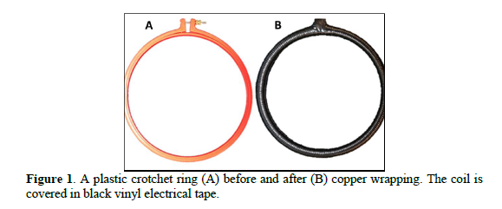
As seen in the Puthoff A-B Generator Phase/Group Velocities are disassociated, this is a product of a photon with nonzero-mass. The A-B Generator is a helical toroid in a circle, thus always accelerating, according to Persinger the phase modulation has the capacity to mediate unlimited information with little energy and phase locking is the key to information copies, the patterns in the EM fields. Karbowski points to this mechanism in terms of information, “the coupling of specific temporally patterned magnetic fields with ‘quantum well’ like point durations and a ‘single’ wavelength might be employed as a carrier upon which specific information could be coded which then penetrates into cells and remains there for an hour”. (Karbowski, 2016b). In other research the Persinger Group has found such a phenomenon as ‘water memory’ of potentials. Memory in the Brain, a water based organ, is related to thixotropy and viscosity, viscosity is increased by the A-B Effect according to Sokolova (McCarron, 2021, ‘Ch. 8: Quantum Consciousness’). One physical attribute to keep in mind is that a toroid with a gap will leak magnetic flux, like the hippocampus and toroids, gapped systems have long range entanglement, as we shall see below in the medical section in dealing with the toroidal hippocampus, which mediates information or memory.

Persinger et al, studied the use of point durations in creating their phase modulated EM patterns for use in entanglement experiments. The point duration is either a 1ms or 3ms delay in the wave form at a given amplitude. It is part of the difficult process of designing a pattern that is based on a neurological functional correlate, “Accurate and precise point durations are essential for producing the sensed presence similar ‘temporal sensing’ sensitivity for cells has been shown for frequency modulated (FM) weak magnetic fields. (Rouleau, 2015)”

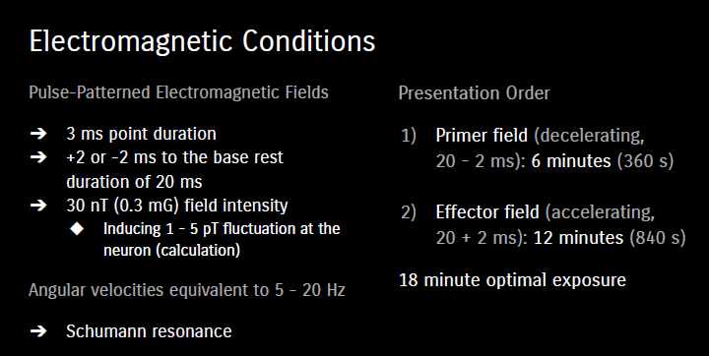

An overall modulation configuration was constructed based on a 20ms starting point, then descending or ascending 2ms between which

“The rates of rotation of the magnetic field that were most effective involved 20ms reference intervals. Addition or subtraction of 2ms as the field moves around the solenoid produced a changing angular velocity.” (Scott, 2015)

1ms Point Duration - Electron | 3ms Point Duration - Proton
- increased free protons  - pH increased aciditiy  - proton expand one planck length  - changes in pH only during increasing angular momentum.  - 1 ms electron pulse 1000 fold increase in photon emissions  “The magnetic moment of the circulating current created by an electron moving in its closed path is 9.274·10⁻²⁴ A·m² (J·T⁻¹ ). Hence the required magnetic field strength would be the ratio or 1.01·10⁻¹ T. If the square of that value (1.02·10⁻² T ² ) is inserted into equation (2), the optimal separation between ideal parallel plates would be ~24 nm. Application of the central limit theorem and assuming the typical standard deviations of ~30 % of the central tendency, the range for 95 % of the spaces would be between 10 and 37 nm. This is the range of the width of a synapse, the interface between neurons. (Persinger, 2014) | - Increased free protons  - pH increased acidity  - proton expand one planck length  - changes in pH only during increasing angular momentum in toroid, descending in solenoid array.  - 3ms point durations participate in Ca Ion channels (aka CamKII in microtubule) (Persinger 2010, 821)  - 3ms gives 1-5nT in the E-W component of the static geomagnetic field (Persinger, 2014)  On the other hand if the magnetic moment of the proton (1.41·10⁻²⁶ A·m² ) is employed, the magnetic field strength required to obtain the energy associated with the hydrogen line is 6.67·10¹ T. If this value squared (44.5·10² T ² ) is inserted into equation (2), the resulting width (a) is 0.93·10⁻⁹ m. This is within the median range of the width of an ion channel found in plasma cell membranes. Most “channels” within the plasma cell membrane are those that mediate the movements of protons. “ (Persinger, 2014)

Recalling that the toroid helix is in a circular arrangement this arrangement with changing rates or modulation have an odd effect that Rouleau finds could violate causality:

Movement in a circle is uniquely interesting because the process would always be accelerating (m·s⁻² ) and a changing rate of this acceleration (m·s⁻³ ) often referenced as “jerks”, would be a second derivative containing the potential temporal non-continuities that could encourage the conditions we assume may be associated with the observed excess correlations. They could spread over the Minkowski four-dimensional field and appear to violate directional causality. In other words the “effects” of these “jerks” could occur before events and appear to violate causal principles but not necessarily the concept of entanglement. The presence of non-local and advanced correlations for geomagnetic effects had been reported by Korotaev and his colleagues (Rouleau, 2015)

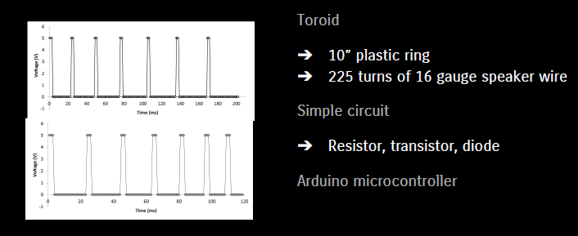

In this way rotation, which affects, entanglement becomes a key part of the process of the functionality of the toroid coil. One of the interesting finding is that given the Earth rotates CCW there is more torque in E-W direction. Orientating to directions was also a very key part of early Nazi German remote sensing experiments before and during WW2 (McCarron, 2021, Ch. 3. ‘Neuroweapons’).

The issue of a second derivative of fields is given as an example where a wave produces a background field for itself by itself.
Quote from section 108, page 349 of the authoritative Landau and Lifshitz (1975)
textbook:
“Since it has definite energy, the gravitational wave is itself is the source of some
additional gravitational field (static g-field). Like the energy producing it, this field is a
second-order effect in the hik. But in the case of high-frequency gravitational waves the
effect is significantly strengthened: the fact that the pseudotensor tik is quadratic in the
derivatives of the hik introduces the large factor λ-2. In such a case we may say that the
wave itself produces the background field (static g-field) on which it propagates. This
[static g] field is conveniently treated by carrying out the averaging described above over
regions of four-space with dimensions large compared to λ [wavelength]. Such an averaging smooths out the short-wave “ripple” and leaves the slowly varying background metric (static gfield).”
(Brackets and underline added for clarity and emphasis.) (Baker, 2010)

Returning to the issue of ‘jerks’ from above it is also used in the HFGW system of Dr. Robert Baker (2010). Baker speaks of jerks as a cascade like effect. The jerks add force (see Chiao et al, 2017), and in a circular constant accelerating circuit the change in force (Δf), the faster the jerks (<Δt) the higher the GW frequency, so that the larger the change in f the better. According to Baker GW waves are too small to use to change frequency, it is better to use EM Waves, which of course could come from GW. The production of gravitons comes through change in mass, so that “each time a mass undergoes a change or build up in force over a very brief time Gravitational Waves are generated. Baker has used laser pulse approach to generate Gravitational Waves in the laboratory @ THz frequencies 10¹² HZ.

Persinger’s Group first began using magnetic fields in 1990 when he designed phase-modulated magnetic fields in a circular array of solenoids, in 2013 Burke was the first to test non-local entanglement affects of the generators, then in 2015 they switched to toroids from solenoids. Some of the physical phenomenon they have observed are

- appearance of longitudinal photon, the non-local effects for nongauge fields for the Ahronov-Bohm effect and altered access to Casimir sources.
- Ahronov-Bohm effect Flux can be curved into a finite toroid (Persinger, 2016)

One effect that is dependent on whether solenoids (superconductors) or toroids were used is that of the phase type modulation used: ascending or descending. In solenoids entanglement effects are observed in descending changing rhythms, in toroids entanglement effects occur in ascending changing rhythms. The basis of consciousness according to Persinger et al is 20ms, with the base unit of the human brain at 1ms. They use 20ms as the starting point for ascending and descending rhythms in 2ms increments, in this case for a solenoid experiment:

“The second derivative component (assuming the circular rotation is always accelerating and is a “first derivative”) was programmed by adding +2 ms or -2 ms to the base duration of 20 ms. For the accelerating angular velocity (20+2 ms) this meant that the duration the field was generated changed through 20, 18, 16, 14, 12, 10, 8, and 6 ms before it began again at 20 ms. The total circuit time was 104 ms. For the decelerating angular velocity (20-2 ms) the duration at each pair of solenoids was 20, 22, 24, 26, 28, 30, 32, and 34 ms before starting again at 20 ms. This duration was 216 ms and was the phase in which “entanglement” effects were conspicuous. Because the circumference of the array of solenoids was 60 cm and the total time before the cycle began again was the sum of the 8 durations (216 ms) the averaged rotational frequency was between 4.6 Hz.” (Persinger, 2016).

One property observed is that there can be a boost by up to 10x in entanglement when the frequencies are phase matched between two entangled coils, “when the rotational frequency of the circular magnetic fields within the 2 vols of spring water had been phase matched the frequency of the product of the magnetic field intensity and the protons magnetic moment, the excess correlations shift towards alkalinity increased by 10x with the non-local volume.”(Persinger, 2016). This effect of an dramatic increase is also observed by Samokhvalov 2016. Solenoid is a different geometry of a toroid, this geometrical basis gives different rhythms for entanglement.

The difference in ascending and descending rhythms is observed by Soroka:

Most of the subjects had volunteered for “relaxation” or “learning” studies so that expectation would be minimal. Approximately 80% of these subjects reported a sensed presence when a slowing frequency-modulated field was first applied continuously with a slightly right hemisphere bias for 30 min followed by the equalized bilateral application of an accelerating frequency-modulated (burst-firing) field for 1 s every 3 s for 30 min. A similar temporal order (slowing frequency modulation and bilateral accelerating frequency modulation presented for 15 min each) of field presentation over the right hemisphere increased the report of sensed presences [46]. Presenting the same field patterns in reverse order was not as effective. (Soroka, 2013)

The modulations of the toroid in this project are controlled through Arduino Board programmed in C++ to add or subtract appropriate intervals for entanglement or in this case creating a masking field with one toroid to interfere with non-local signal transmissions aimed at the object surrounded by the masking field.

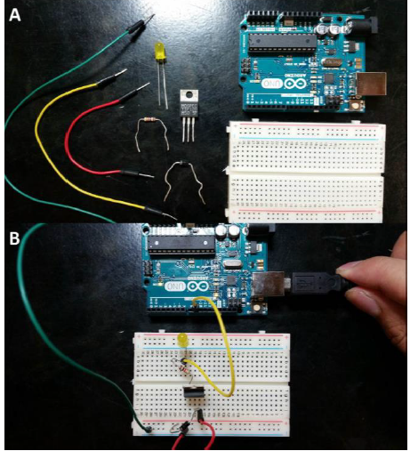
(Arduino Micro-controller phase modulator, from Scott 2015)

A-B Generators as Transcerebral Magnetic Stimulation (TCS)

The A-B Generator is referred to as a TCS device rather than a Transcranial Magnetic Stimulation (TMS) device, which is used in treating epilepsy with different coil constructions and patterns around brain areas. Saroka provides an explanation to the difference between the two:

The fields in our studies are usually applied for about 20 min to 30 min while the subject sits blindfolded in a quiet, darkened room (acoustic chamber). To distinguish the procedure from transcranial stimulation (TMS) whose symmetrical pulsed field strengths are about a million times stronger, the term transcerebral stimulation (TCS) has been employed. We had reasoned that the more the complex pattern of the applied fields approached the form of intrinsic cerebral patterns, the less the intensity required to produce subjective and electroencephalographic changes. The rationale was similar to strategically developing molecular structures of pharmacological agents to be congruent with neurotransmitters for receptor subtypes. For analgesic effects in rats, for example, exposures of only 30 min to appropriately patterned magnetic fields with intensities of only 1 μT were equivalent to a subcutaneous injection of ~5 mg/kg of morphine mediated through micro opioid receptors (Saroka, 2013) [for more on the pharmacological aspect of this technology see ‘Entanglement Medicine’ git repository]

The main difference between TMS and TCS: TMS is 10⁶ magnitudes larger then TCS however in terms of magnetic field strength TMS is about 5μT whereas TCS is 1-5μT so the end product is in the same range produced by different mechanisms in terms of Tesla (magnetic standard units) generated. TMS uses heavy loads, higher voltage, compared to TCS to achieve the same effect.

III. Brain Profile: Havana Syndrome, Epilepsy and Non-Local EEG Studies

Profile of an Attacked Brain
The ideal one can create a methodology to distinguish neurological damage from non-local signals and other brain impairments, such as Mild Concussions (mTBI), or epilepsy is argued in the following by examining brain waves during impact and gray matter in brain areas impacted. The question of whether it is possible to distinguish Havana Syndrome was answered by Balaban et al (2020) in what is akin to a ‘Blade Runner’ cyborg test by measuring the eyes response the team was able to develop a methodology that does distinguish between other brain injuries and Havana Syndrome:

This is the first report that examines the function of these individuals on a test that examined binocular disparity-driven eye and pupil movements during the acute time period after exposure. The patterns of response in these individuals are markedly different than those seen in a group of individuals with usual acute mild traumatic brain injury and from controls with no injury. The results from these tests permitted an objective discrimination of the groups with >91% accuracy and no confusion between the Havana subjects and the subjects with acute mild traumatic brain injury. This pattern difference may be a useful screen for individuals who report a similar exposure pattern. Furthermore, their distinctive presentation may help guide in treatment decisions to address the mechanisms that contribute to their unusual symptom complexes. At the current time, however, this remains an empirical observation and more work is needed to study the findings. (Balaban et al, 2020)

It is interesting that an eye test which also showed disparity in the visual cortex in Verma et al, is affected and can be used as a measure of differentiation. Again, Norseen focused on the visual cortex, conceived as a photon field. Bandyapadhya’s Group in Japan has studied the antenna properties of eyes and DNA (Singh, 2018). Balaban also found that there was a differentiation in pupil size of Havana Syndrome, this was also seen in highly hypnotizables where their pupil size is also reduced (Kellio, 2011).

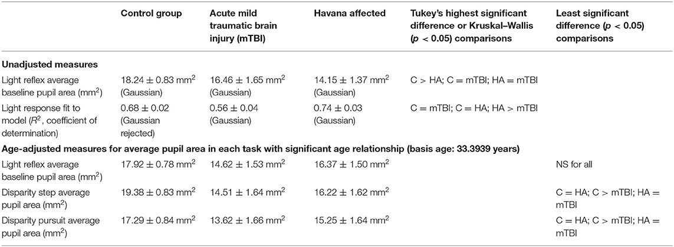
(Balaban et al, 2020)

One of the first objections you will hear regarding the concept of EM potentials being able to affect the Brain is that the normal molecular pathways are bypassed by using EM potential energies. In other areas relating to molecular biology a former Yugoslavian scientist, U. of Belgrade, I. Cosic in 1994 proposed an alternative to the JAK-STAT pathway based on molecular resonance, Resonant Recogntion Model, also derived from Frohlich, originally molecular resonance was credited to P. Jordan. Readers of Quantum Physics and Quantum Biology that have studied the originator of these ideals Pascual Jordan, the former Nazi physicist and secret weapons developer, with molecular resonance, which was attacked by L. Pauling. It was Jordan working with Berlin-Brain Institute, the sister institute to the one in Russia that Kropotov worked at in a later era, that first proposed a molecular resonance explanation for molecules being ‘attracted’ to each other. This was rejected by the scientific consensus of western scientists who adapted Pauling’s ideals. Jordan’s ideal was correct but misapplied. At the Brain Institute he worked with the founders of modern molecular biology (McCarron, 2021, ch. 8 Quantum Consciousness) who were captured by the Soviets after the war and assigned to the Soviet Nuclear program out of which it is claimed remote biological influence developed, out of labs run by Germans as Soviet prisoners. So the Soviets had a more open response to resonance theories and the combination of Quantum Effects on Biology as a recipient of German knowledge in these areas after the war. Kravkov notes the adoption of Resonance by the Soviets, including such concepts as bioeffective frequencies, “the resonance effect can be observed if the natural frequency of any structure has a natural frequency of oscillatory or rotational motion, which coincides with the frequency of the incident radiation…. [see synchronization above]. Resonance also takes place in cases when the frequency of absorption of an EM wave of any molecule coincides with the frequency of incident radiation.” (McCarron 2021, Ch. 8). It is also in this area of research that viscosity becomes an engineering issue for heavy water (deuterium), it is easy to forget that the founders of Quantum Physics were mostly Germans at the time, 1930s when their theories were first beginning to be validated as the Nazis rose to power. I have argued in McCarron 2021 that all western remote influencing technology originates from the Nazis. So the question then becomes how do such topics apparently unrelated, human brain and production of heavy water for nuclear arms, have to do with each other?
Nuclear or atomic reactions are not usually thought of as occurring in our brains or body in general. The reason we think is because our brains are a very large network of electrical reactions, electricity coming from the magnetic interaction with an electrostatic field influencing how the electrons interact, quantum interference. This happens in the water based neurons of the Brain as magnetic fields influence electrical pathways triggering molecular reactions from either electron or proton tunneling in the neurons themselves, in their neuron’s microtubules as discussed above.
Persinger supplies a theory explaining how thixotropy and viscocity influences neurons, including the generation of EEG amplitudes through Casimir Effect, this is a key element as we shall see that EM influences thixotropy (liquid layer seperating, phase states, boundaries) which impacts viscosity which may explain the changes in gray and white matter brain volume as seen by Persinger in his independent studies not directly related to Havana Syndrome and those of Verma et al specifically studying Havana Syndrome.

A-B, Casimir, EM Potentials and Brain Waves

Brain Waves are EM transmissions that are produced through the neural networks in the human brain they are affected by EM fields the following ways (Ye et al, 2019):

1. direct alteration of neuronal excitability
2. alteration of ion channel functional
3. alteration of synaptic transmission
4. interruption of ephaptic effects (electrical conduction of a nerve impulse across an ephapse without the mediation of a neruotransmitter)

As we are dealing with EM potentials rather then electrical impulses in terms of these generators we are interfacing with quantum effects through the A-B generators.

Persinger et al have argued that the process of affecting brain neurons with Ahronov-Bohm generators is one that involves not just the A-B Effect, also the Casimir Effect and the influencing of electrons with vacuum interference patterns from the Casimir Effect at around 23nm width, also arguing that this affects the 10nm width of the neuron synapse. These vacuum fluctuations, what Norseen refers to as Zero Point Energy (ZPE) have orbits that are half-virtual (wave) and half-real particles (concretization or quantization), Out of which come through the interaction of magnetic A Vector Magnetic Potential with electrostatic field (E) electron and proton pumping from the Casimir Effect induced vacuum fluctuations, there is a gravitational analog to this EM version as well. Koren explains the interaction between EM and Casimir:

The spatial dimensions that define the synapse and the ion channel were evident when the energies that converged Casimir and traditional magnetic forms were equated. The specific values required the presence of a magnetic field strength that when multiplied by the magnetic moment of the proton or of the electron resulted in the energy of the neutral hydrogen line. Subtle differences in the magnetic moments for the electrons spin and orbit, the proton’s value and the slight discrepancies revealed features that could connect fundamental features of astronomical phenomena with those that contribute to quantum processes in the physical and chemical systems that define the brain. (Koren 2016)

One important element in their understandings of how A-B works with Brain chemistry is that of the 1.42 GHz hydrogen line, a common universal wavelength. As explained by Saroka:

Once measured almost exclusively in large space the ubiquitous 1.42 GHz hydrogen line has been detected over terrestrial water. The potential transient emissions of this universal frequency from the human body and brain could be very significant for the interface between these functions, including the units of cognition coupled to action potentials (~10⁻ ²⁰ J per action potential) of neurons, and transmission of information over larges distances as either local or non-local processes. The detection of human enhancements of 1.42 GHz transients within a radio-quiet area requires angular velocities of about 3 to 4 m per s to and from the receiver. The angular momentum of each electron when multiplied by the hydrogen line frequency would result in flux densities that are in the same order of magnitude as the measured photon emissions emitted during cerebral function. (Saroka, 2013)

In other works, the Persinger group has related neuron brain biophoton transmission to Brain-Computer-Interfaces.

A cell membrane is typically 10nm which falls within the Casimir Effect scale (.1-25nm), the relationship between the electron, magnetic A vector potential and protons, in terms of ion channels and transmembrane potentials through which protons (H+) as ions: Na+ , K+ or Cl flow into the cell body. Remembering that water interact with magnetic fields we see the impact of such proton pumping, “In fact the proton shells near surfaces that constitute Pollack’s interfacial water configurations display potential differences that are comparable to those attributed to disparities of concentration for potassium and chloride. Quantitative links between plasma membrane physics and quantum-related values have practical applications.” (Koren, 2016)

Here the practical application is seen in that the A potentials have a connection to ion channels for K and Cl according to Pollack. Koren explains the connection to entanglement as a photon-electron coupling due to the space formed by the A vector potential and the electron drift:

We have been considering protons through proton channels as the quintessential mediator of transmembrane ion properties and that other ions, such as Na+ , K+ or Cl are epiphenomena secondary to the required water molecules associated with transport of those ions through the membrane. However in a parity-based universe the proton should be matched with electron properties. We suggest that the states of matter allowing these transportations may be created by the space formed by the A vector potential and the electron drift. This occurrence could optimize the conditions for the type of photon-electron coupling associated with entanglement (Koren, 2016)

Persinger identifies photon entanglement with Orthogonal Fields (A Vector Potential) in other studies.

Koren then explains how this relates to Angular Momentum which is intrinsic to entanglement where Angular Momentum (p) is derived from magnetic quantum number (j):

“Effectively the same function that is a source equation for quantum phenomena when applied to a larger rotating aggregate produced predictable quantities of photons as a function of specific intensity weak magnetic fields. That function was the relationship between Bohr’s orbital magnetic moment of ep·(2m)⁻¹ where e and m were the charge and mass of the electron, p was the angular momentum of an electron moving in the orbit, and the quantized relationship. The quantized relationship for angular momentum (p) was jh·(2π)⁻¹ where j was the magnetic quantum number and h was the traditional Planck’s constant. When j is assumed to be unity [1] the value solves for the Bohr magneton or the orbital magnetic moment of an electron. (Koren, 2016)

Spins are related to AM, electron spins are transported into protein molecules:

“The second solution involves the A vector (magnetic potential) directly. The relevant property of the magnetic vector potential is that is elicits a phase difference and, potentially, interference between partial waves. The vector potential of the earth’s magnetic field cannot be shielded. According to Bokkon and Salari [29] “oscillations of dephasing non-conductive (fixed) electrons could influence conductive mobile electrons” and as a result coherent transport of the mobile electron spins into surrounding semiconductor protein molecules could occur. This is consistent with Cosic’s delocalized electrons that maintain the coherence of the propagating electromagnetic wave of information along the backbone amino sequences of the proteins in signaling pathways.” (Koren, 2016)

Koren equates the ability for such transport to that of Cosic’s alternative magnetic molecular pathway using Resonant Recognition Model which mirrors the electrochemical pathway of JAK-STAT. This is similar to Norseen’s use of MT-10 as electrochemical biocomputation and MT-13 as magnetic biocomputation. In this regards of computation Bandyopadhyay et al have found that there are binary streams of neurons in axon core, neuron membrane. (McCarron, 2021, Ch.8) According to Hameroff (2014) MT cilia are quantum optical devices, MT cilia are also in the retinal rods and cones of the Eye, detect photons quantum information. Dotta (2014) has found that for Microtubules that the temporal pattern is more important then amplitude thresholds:

“The close correspondence between the intrinsic rotational frequency (9.6 Hz) of the angular accelerating magnetic fields and the 9.4 to 9.5 Hz conspicuous peaks in power density of photon emissions from the microtubules several minutes after removal from the field may suggest a transient “representation” or “memory” of this second derivative, rotational frequency within these aggregates that was later expressed within the photon emissions. The results of these experiments indicate that the strength of the applied magnetic field is not required, as also argued by Cifra et al. [13], to exceed the threshold to compensate for thermal agitation. The temporal structure of the applied magnetic field, particularly when it simulates intrinsic biological or biochemical processes, may be more important than previously considered.” (Dotta et al, 2014) [emphasis added]

In research done by Ye et al (2019) in the treatment of seizures studied the effect of EM on epileptic seizures. The effects of time varying (phase/frequency) magnetic field are generally believed to be caused by its induced electric field and the establishment of a transmembrane potential.”
in Aninos 1991 magnetic field alters function of pineal gland-magnetosensitive organ that transduces environmental information of the light-dark cycle and earths magnetic field into an endocrine message”
release melatonin. (Ye et al, 2019)

EM among other products releases endocrine messages through it’s interaction with magneto-receptive areas of the brain, such as that in the visual organs which contain magnetoreception.

Neurons and Brain Waves
With the insights of the contribution of the Casimir effect to neuronal firing at the nano-scale of the Brain (see McCarron, 2021, Ch8. Quantum Consciousness), Norseen talked of the Casimir Effect as energy of the vacuum (ZPE), we are now ready to see how these neuronal firings that produces EM signals are quantized. The quantization of the shallow level (scalp) of the Brain is performed using EEG, for instance Kropotov’s use of QEEG. There are other ways to study the brain, such as the topological based sLORETA as used by Persinger in some of his studies, fMRI was used in the Verma et al study of Havana Syndrome. Each provides different insights into the functioning of the brain’s various areas, typically referred to as Broadmann Area’s reflecting functional differentiation in the different parts of the Brain. EEG is used to estimate the magnitude output of magnetic fields (μT) at the various locations in the Brain, such that an area of interest such as EEG location F7 is mapped to the Broadmann Area 44 or Broca’s Area. The waves are categorized into different wave zones, such as theta 4-8Hz, Alpha 8Hz-12Hz, Gamma >=30Hz, These waves have a directional flow from rostral-cuadal (front-to-back) axis 4m/s⁻¹, which recycles every 25ms (Saroka, 2013). These are not definitive or universal measurements as placement of EEG sensors is not universal. Below is a standard mapping of EEG locations, later we shall reference different EEG locations to brain area functionality..
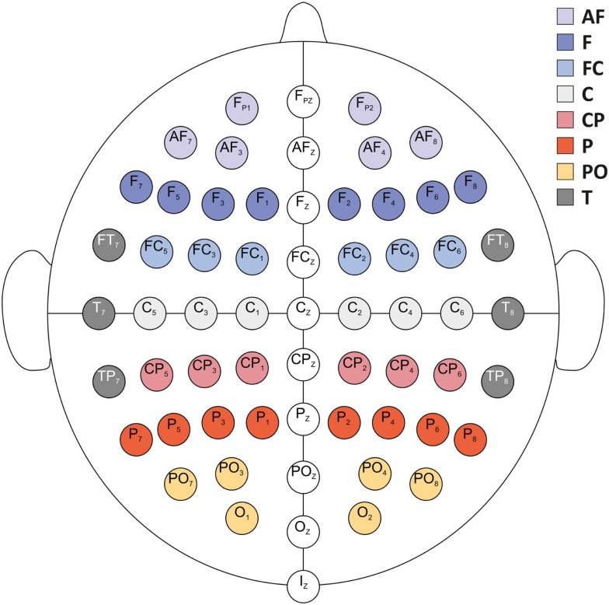
Grabner, 2012

EEG is used by Persinger et al to study the effects of non-local entanglement using A-B generators, from these quantitative studies they have formulated a possible profile for non-local transmission in the human brain, called the Harribance Configuration, named after a test subject studied by many others in non-local transmissions. We shall encounter this configuration below. This configuration also bears functional equivalence to areas affected by Havana Syndrome, see below, and in Temporal Lobe Epilepsy Patients without Hippocampal Lesions (HL). So that it may be possible to have a loose profile pending further research of non-local brain activity, which could be used for detection and deployment of countermeasures if coming from a directed source.

Experimental Results of Generators on Human Brain:

A cold war warrior with British Secret Services whose specialty was in microwave technology as part of Electronic Warfare, Barry Trower, once pointed out that a frequency of a 6.6Hz signal focuses at a human brain causes such symptoms as anger and paranoia. This was confirmed by Scott et al, with a frequency of 6.5Hz during entanglement experiments with A-B Generators between entangled pairs over long distances, non-local (Scott et al, 2015). They found that EM waves of this Extreme Low Frequency (ELF) when correlated with emotional scoring showed a correlation between anger and this frequency, “...subjective experiences, as measured by the Profile of Mood States (POMS), indicated significantly increased excess correlation for scales by which increased anger and decreased vigour are inferred.” (Scott et al, 2015). In this effort to understand the effects of EM on the Brain we have both historical testimony of Dr. Trower, and we have experimental confirmation of this impact on the Brain from Scott et al. Meaning, EM has an effect on the Brain, here delivered via sonic means.
A Russian researcher found an alteration in the parietal region when studying the effects of what they termed ‘spin fields’, spin directly related to entanglement, using the same instruments as earlier Soviet scientists found that in EEG studies that there was a difference in alpha rhythm when applying a positive emotional stimulation via a generator:
Encephalographic experiments to study the effect of SP modulated by a positive emotional component indicate a change in the zonal distribution of the α-rhythm with its highest concentration in the frontal-pretemporal region (in the initial state, the localization of the α-rhythm is the occipito-parietal region). An increase in the amplitude of the α-rhythm up to 50 μV and an improvement in its modulation were noted, which indicates an increase in the ability for abstract thinking, an increase in efficiency in making decisions and actions. Based on the results of the experiments, the following conclusions can be drawn: 1. Psychotronic systems based on the use of spinor fields are a real fact. Their use is not limited by distance and can cause the following consequences: making erroneous, inadequate political, economic and military decisions; aggravation of social and inter ethnic relations, etc. 2. Psychotronic systems with modulated SP in a positive emotional component can be used to smooth out negative psychophysical factors in large areas (reduction of terrorist manifestations and crime, drug addiction). (Kraznobryshev, 2009)

The findings regarding occipito-parietal region are also found in Lehman 2015.

Above we covered some of the findings of the Verma et al Havana Syndrome study. In it there was differentiation in gray Matter and White Matter of the Brains of those affected. Verma et al shows that the primary areas affected were the visualspatial circuitry, as mentioned by Norseen BA 17 & 18, which is to say the visual perceptrons, Norseen relates, percepts and imagination are photon fields (Norseen 1999), and typically aside from the audio cortex, another area affected in Havana Syndrome and targeted by Norseen in his studies, the main inputs to the Brain, as well the human eye serves as a magnetic antenna cavity resonator, or interferometer. Norseen mentions a third area, Broadmann 44, Broca’s area. BA 17,18 visual cortex of the Brain becomes of prime interest if a sickness has it’s source outside the body from a EM based transmission, affecting the interface with the environment, visualspatial and audio cortex, sometimes also referred to as temporal cortex, having connection to rhythm, people with enlarged Amygdala’s also have a better rhythmic sense (McCarron, 2021, Ch. 11). Verma et al also show that the most affected side of the brain was the right side, which Persinger shows the right temporal lobes to be most affected by non-local effects, also Right Temporal Lobe Epilepsy (RTLE). In RTLE there is a difference as seen below between those with Hippocampal Lesions (HL), that do not match the Non-Local Transmission Profile (NTP) and RTLE-No without HL that does match the profile of NTP as interpreted from the combination of symptoms and effects from Verma and Persinger. Persinger has noted that the right parahippocampal is affected by EM, this may suggest that the difference between RTLE-HL and RTLE-No may have something to do with Hippocampal processing of EM. The parahippocampal region is affected by gravitoelectromagnetism most (Persinger and Soroka 2014); parahippocampal could serve as singularity, curvature singularities form from colliding Gravitational Waves (Baker, 2010), since there is a gap that radiates magnetic flux with the parapippocampus having a toroid geometry (Persinger 2013), Persinger speaks of retrieval in Harribance Configuration (HC) experiments from parahippocampal structures on the right side. Persinger’s Group suggests that the Hippocampus interacts with a singularity and thus virtual particles, which transition to real particles, protons and electrons.

In Epilepsy, which has a comorbidity of obesity (also see McCarron 2021 Ch. 11 for relation of increased EM and obesity in Rats as studied by Persinger), additionally death rates from Epilepsy are increasing in the United States (DeGorgio, 2020). There are similar differences observed in gray matter with a decrease reported in patients:

It was reported that gray matter volume was associated with cognitive functions. Decreased gray matter was observed in epileptic patients. Most important area where gray matter abnormalities occurs is hippocampus. Other areas include thalamus, parietal lobe, and cingulate gyrus. Changes have also been described in the parahippocampal gyrus, middle temporal gyrus, superior temporal gyrus, inferior temporal gyrus, fusiform gyrus, temporal pole, entorhinal cortex, amygdala, and perirhinal cortex. It was reported that abnormalities of gray matter are essential to produce reductions in episodic memory recall. Most commonly seen cognitive dysfunctions due to gray matter abnormalities in children are decline in verbal intelligence quotient, freedom from distractability, and executive function and mental slowness, memory impairment and attention deficits in commonly observed among adults. (Saniya et al, 2017)

These abnormalities in epileptic patients correlate with the changes observed in gray matter and white matter in Verma et al. not only that the same brain areas were affected in epileptic patients and Havana Syndrome patients, another interesting finding in relation to gray matter is that of Amygdala and the ACC in Highly Hypnotizable and non-highly hynotizable groups, with gray matter differences observed (See McCarron, 2021, Ch. 11 ‘Hypnosis in Warfare’). The question of whether a profile has already been seen for non-local monitoring seems to line up between the work of Persinger’s Group and that of the results of Verma et al study of the irradiation of US Diplomats in Havana and the physical changes to their brains, and we can also see a correlation with Epilepsy.

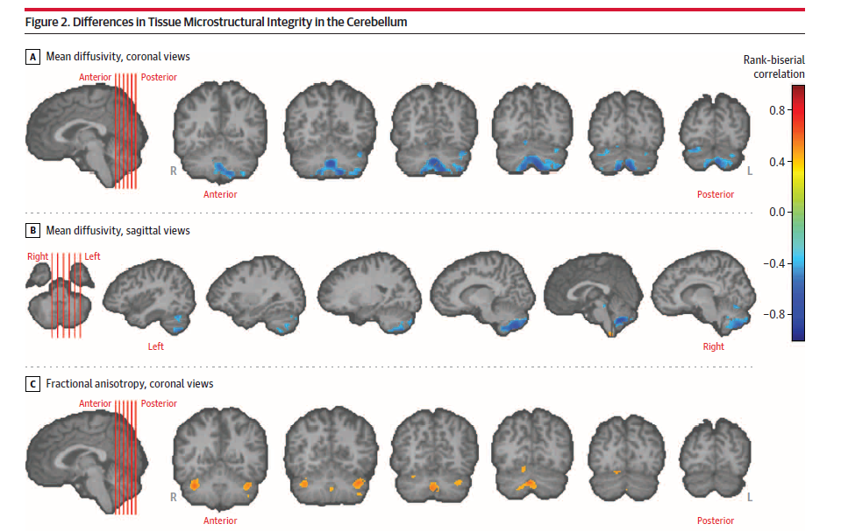
(Verma et al, 2019)

Broadmann Areas and EEG Sensor Locations for areas affected by non-local effect:

1. Visualspatial

- BA 17, O1 and O2 projected to the occipital gyrus and cuneus, visual processing of information from the retina, see retina as antenna section. Cuneus, was an area of noticeable difference in Havana Syndrome Study (Verma 2019), it receives visual information from same side superior quadrantic retina. Pyramidal cells in visual cortex of the cuneus project to extrastriate cortices (BA 18,19) modulated by extraretinal effects: attention, working memory, reward expectation.

2. Audio/Temporal Cortex

- BA 22, EEG T3/4: cited by Norseen working in tandem with BA 44 (Broca’s area in left hemisphere). Sentence generator, Attend to happy angry voices, Deductive reasoning, auditory language, non-verbal sounds, previous eye movements. Categorization and organization, visualization and auditory cortex. Right (T4) and Left (T3) Superior Temporal Gyrus. Also, T3/4 is near the insula, which functions: copying emotional tones, object recognition anxiety occurs in relation to it’s closeness to the Amygdala. BA 22 is part of Wernicke’s area, another language processing area of the brain. epileptic aphasia can occur from BA 22 as well as Broca’s Area. BA 22 in Havana Syndrome study is the Auditory Network, also referred to as temporal network by others. Auditory Network L/R Superior Temporal Gyrus and Right Thalamus. The Auditory Cortex comprised of BA 41,42, 22 is the seat of processing incoming signals from the environment, Rotation also relates to the Brain as rotation is used to protect existing memories from incoming environmental stimuli by rotating memory in a second orthogonal direction from the incoming stream of inputs, “a rotation of the coding dimension in the neural population cortex protects memories of prior events from interference by incoming stimuli” (Libby, 2019)

In Scott 2015 spectral power densities correlated over F4 and T4 for non-local interactions.

“A cluster of significant non-parametric correlation coefficients could be identified for right hemispheric global power during the second half of the Effector field sequence containing somewhat after the termination of the field.” (Scott 2015, 679) Only temporal lobes were obviously effected by the unusual theta and gamma power changes.

T3/4 change in coherence is tied to function of the phase (freq) of the experiment and type of magnetic field (Scott, 2015, 683). Diminishment of coherence power theta right temporal lobes of pairs separated by 6000km. Similar diminishment in the caudal temporal lobes (T5,6) during the effector field. In a test of non-local changes, one person listened to 6.5Hz tones, in their EEG there was a peak in the temporal lobe when the tone sounded, in the second person there was a trough in the EEG which is indicative of entanglement with inverse correlations.

Temporal Lobes:
Focus of studies by Persinger Group as area most involved in non-local interactions. In 2003 Persinger conducted a twin study where one twin had an 8 element solenoid circuit placed around her temporal lobes, the other twin had no array around their temporal lobes. There was a change in the Theta band from 5.0Hz to 5.9Hz when the EM circuit was placed around the other twin. Non-local interactions without changing angular velocity em fields in the second twin. (Scott, 2015, 663)

In a suggestion of the involvement of BA 22 another study found audio waves as generators of excess correlation rather then visual stimuli:

“Burke (2013) found that when a toroid was placed over the head (level of temporal lobes) of each individual in a pairs separated by about 400km. LORETA profiles indicated excess correlation in the activity within the temporal lobes of both subjects when one pair was exposed to sound patterns. The effect was not observed with visual stimuli.” (Scott, 2015, 667)

In a pilot study regarding an Epileptic patient and her hearing voices Persinger notes that the epileptic patient had a unique profile for different seizures. For instance in one seizure experience her voice would become more ‘machine like’ and her pronouns shifted from ‘I’ to ‘we’ while also reporting tinnitus. There was a difference between her pronoun use of I in the beta band over T3 and T7, left temporal lobe, with 70milli vols activity. When she used ‘we’ there was a higher (fast) amplitude over T3 and T4.
“she reported ‘transmissions’ which usually involved more complex information… When this occurred there was a re-normalization of the EEG. When the transmission ended, the unusual profile of T3 and T4 returned. There was additional similar activity over F7 and F8.

“During the experiences that would be classically labeled as ‘intrusionist’ the activation score for the low beta power within the right parahippocampal region more then doubled. This area and related hemispheric discrepancy are similar to that associated with panics that can occur suddenly in this group of patients.”
Persinger et al, (2015) LORETA predicts Electromagnetic Sensitivity and ‘hearing voices’ in a predictable, increasingly prevalent subpopulation

3. Language Processing, Broca’s Area

- BA 44, Right and Left Inferior Frontal Gyrus (IFG). Functions: working memory (visual/auditory), attention filtering, facial emotion processing, sustained attention, mirror others, grapheme-to-phoneme, phonemes. Epileptic seizures start at F8 (Quintero-Rincon, 2016). Frontal Eye field left and right, see Shirer, W.R., et al., Decoding subject-driven cognitive states with whole-brain connectivity patterns. Cerebral Cortex 2012. . BA 44 according to Verma 2019 contains Frontal Operculum and IFG [see Norseen on IFG and Biofusion].

4. Memory Retrieval/Storage, Parahippocampus

- EEG T5/6: parahippocampal gyrus (Scott, 2015) dorsal hippocampal commissure mediate information between the hippocampal formations within left and right hemisphere (Scott, 2015) “topographical map clusters indicated the domain of maximum coherence was within the right caudal hemisphere within the volume occupied by the parahippocampal gyrus.” (Scott, 2015)

- T6- right caudal temporal lobe, area of most excess correlation in Harribance Configuration right

- Isoelectric lines (anisotropy) switched from clockwise to counterclockwise at onset of field.

- the changing rate creates a second derivative in the magnetic field. A second derivative is a secondarily-Induced Magnetic Field. Analogy: influencing the change of a change (Persinger, 2010), also see Chiao above for Gravitational equivalent.

- “According to Bear (1996) this 7-40Hz superposition may set the condition for interaction between the hippocampal process associated with memory consolidation and retrieval and its integration with information represented within the entire cerebral cortical manifold.” (Rouleau, 2015b)

- Hippocoampus is toroidal, leaking magnetic flux. It is strongly affected by the phase vector of B. (intensities match Geomagnetic Field and Schumann Resonance) (Rouleau, 2015b)

- Magnetic Fields and Amygdala: “Magnetic fields may suppress seizure by altering cellular properties. Repeated stimulation of the amygdala can prompt after discharges and motor seizure . Potschka et al. found that chronic exposure of rats to a 50-Hz, 100-µT magnetic field exerted weak inhibitory effects on some seizure parameters in amygdala kindled rats ). In another study, application of rTMS during amygdala kindling prevented seizures. A cellular mechanistic study revealed that rTMS administration inhibited kindling-induced changes in the electrophysiological properties of hippocampal CA1 pyramidal neurons.” (Ye et al, 2019).

- “Rose and his colleagues found that a temporal pattern of electric current associated with a single priming pulse followed 150 ms later by four rapid pulses (equivalent to ~100 Hz) resulted in significant LTP [memory consolidation] when applied to hippocampal slices. When this pattern was transformed to weak magnetic fields in the order of 1 μT and applied to the entire animal before learning a spatial task, the disruption of the memory was as powerful as complete depolarization of the hippocampal region by direct current.” (Dotta, 2014)

Harribance Configuration, Increased Power Shifts in EEG SPD and Gray Matter Changes:

The Harribance Configuration (HC) was the configuration argued by Persinger’s Group for EEG and Brain Wave activity for non-local transmission. The human brain is considered to be a collection of microstates that last 80-120ms, these microstates are affected by EM differently in different parts of the Brain based on functionality. Some properties of this configuration are that the main EEG sensor areas involved are on the right side of the brain F4,F8, C4, T4 (right temporal lobe where entanglement symptoms occur as well as the locations related to RTLE) according to Hunter et al 2010. Persinger has found that T4, F8 also T6 is an area of concern to entanglement experiments, F8 and T4 most important for non-local interactions between reader and target (receiver and emitter).

The technical transmission of the HC uses peak-to-peak intensity 1μT 3ms point durations (protons) [shown to slow melanoma growth]. The HC was digitized into a 3d magnetic field (A Potential). It was delivered by 8 complex signals (4 left, 4 right) from an 8 solenoid EM array. The digitized signal was converted to 44100Hz sampling rate, with a signal output of digitized signal converted to 44100Hz sampling rates, 2μV 10% max. audio amplitude. The signal was transmitted for 20s per 1 min. In power shifts the shift is 2μV shifts in EEG when applying HC, for instance the T4 location shifted up 2μV. In a pilot study they tested the psi abilities of a non-psi person and found increased psi ability, it was a pilot study of n=1, so more experimental research would be needed to see if there is a profile that is manifest with non-local effects such as A-B generators.

Saroka has noted that specific brain functional areas are affected by the HC:

increased intercortical coherence with EM frequency modulation leads to increased activity in the ventral temporal lobe, increased gamma power within the right prefrontal region and the anterior portions of temporal lobe. (Saroka, 2013)

Again another commonality with epilepsy is that Saroka noted that the profile is similar to that of complex partial epileptic-like subjective reports which is known to be associated with focal stimulation of the temporal lobe. (Saroka, 2013)

The HC affects the following Brain Wave bands the most:

alpha 8-12Hz
theta 4-8Hz
Gamma 30Hz and greater
[Brain waves have a high Q-factor, the operating radiation bands]

In a separate experiment in 2016 the group tested entangled gamers to measure their brain waves during flow state, non-local interactions of brain citing the following areas of the brain as being involved: right parahippocampal gyrus, right occipital, temporo-occipital junction, parietal region, orbitofrontal cortices (Lehman, 2016) Maximal flow state has decreased activation in the left interior frontal lobe (T3), and increased power in 7-8Hz, 27-28Hz, 42Hz, theta and gamma waves affected.
The studies have shown that in terms of brain waves, that in various studies from entangled gamers, Harribance, Epilepsy, there is a change in the Theta and Gamma bands of waves. Norseen has focused on 14Hz or 10Hz in the alpha band, this was also shown by Kernbach in his entanglement experiments. However, there is a direct convergence between Persinger’s Group findings and that of Norseen regarding Theta band, which he speaks of as a lower harmonic reflection of the Alpha band:

“NS Model [Norseen Semiotic] our Alpha [8-12Hz] 10Hz brain maintains a complete NS=O,IR as an holographic… in our minds eye of Panum’s Fusion Space, accessible to us as mental imagining via signals from the Anterior Cingulate Cortex (ACC) and fusiform gyrus. Now we also have a complete Theta State 5Hz Brain NS=O,I,R.. self image of ourselves…. once a powerful Semiotic is set up… one that BioFuses the 10Hz with the 5Hz… you have one Big Mother of All Semiotics...and in this case ZPE [vacuum fluctuations, Casimir effect] is flowing fully at all levels of brain-behavior-memory-new channels… you are not only the signal, but you are the ZPE” (Norseen, Laurie, 2002)

Rouleau et al (2015b) studied the gray and white matter changes associated with the Harribance Configuration finding specific power increases associated with the HC which enhances theta power in gray matter

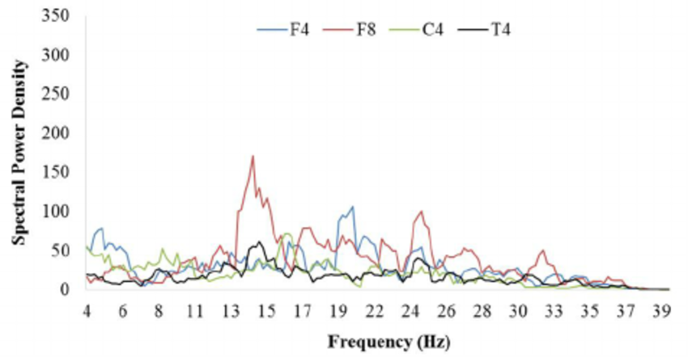

SPD for EEG Locations in the HC: F4, F8, C4, T4 (Rouleau, 2015b, Fig. 2)

Here (Rouleau, Fig 2) we can clearly see that there is a spike at 14Hz in the F8 location, the theta spike is in F4. They found that HC applied to dead brains there is a difference in theta in gray matter, but white matter was unaffected. When applying the C4,T4 components of HC resulted in increase μ volt power within the theta band in gray compared to white matter. When testing during a live Harribance reading of a target in 1m proximity of each other the reading pair test increased theta in right temporal and parietal regions. (Rouleau, 2015b)

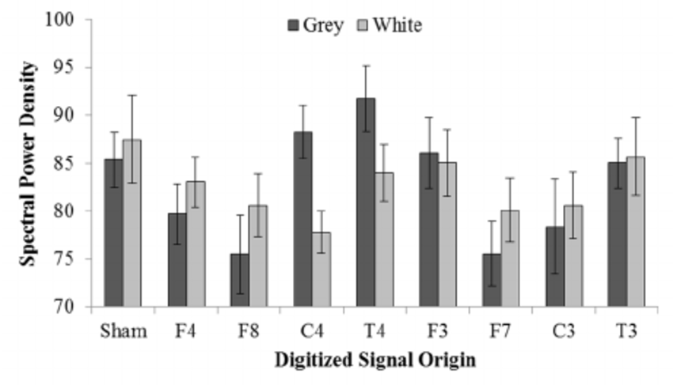
gray and White matter difference over T4 EEG location, temporal lobe (Fig. 5. Rouleau 2015b)

When the gamma power increases there is a difference in gray and white matter, citing primarily the T4 location as being involved. Significantly increased beta2 power was observed in the left caudate nucleus (T4 rhythm applied) relative to right caudate nucleus, showing like the Havana Syndrome right side bias in non-local experiments. Also, Beta2 SPD increased in left hippocampal body. When applying the F4 component exposure beta2 SPD increased right temporal stem size on dead brains. F8,T4 band was enhanced for the HC at 20-30Hz. The HC specifically enhances theta power in Gray Matter within the central and temporal regions. The Left side is not affected. There is a significant increase when applying the HC T4 component.

Theta Gamma Brain Matter Effect:

- Gamma: right temporal lobe, both white and gray matter affected (Rouleau, 2015b)
- Theta: right central and temporal gray matter affected, not white matter. (Rouleau, 2015b)

The HC affect overall the bands from the Schumann Resonance 7Hz up to 40hz:

“Hunter found when Harribance sat proximal to target there was a duration dependent increase in the degree of cross spectral coherence within 19-20Hz [Beta2] band (and the 30-40Hz [Gamma] band) between readers (HC) right temporal lobe and the targets lobe. (Rouleau, 2015b). Harribance, reader, showed increased photon emissions while Harribance was reading target.

Harribance showed during reading of target most activity in C3,T3 (left temporal lobe), as reader of target. With test on brain tissue (n=3) T4 increased theta and beta2 in left caudate nucleus, C4 also had changes.

Overall, we can see that in both Havana Syndrome, Epilepsy and Non-Local Brain measurements there is a convergence in the Right Temporal Lobe, with specific EEG locations identified, and functional brain areas. In some next steps in studying the problem is planned to do EEG Machine Learning Analysis on Epileptic patients with symptoms matching those of Havana Syndrome to see if there is any convergence on EEG locations to brain function between the two, aside from the pilot studies of Kernbach and Persinger.

Conclusion:

Brain Areas by different research groups:
Verma et al Havana Syndrome | - Auditory cortex: Right and Left Superior Temporal Gyrus, Heschl’s Gyrus (BA 22*, 48); Right Thalamus  - visual-spatial subnets: R & L Frontal Gyrus, Superior Frontal Gyrus, Precentral Gyrus (BA 6); R & L Inferior Parietal Sulcus (BA 2, 40, 7); R & L Frontal Operculum, IFG* (BA 44,45, 48); R & L Temporal Gyrus (BA 37)  - Cuneus (BA 17)*  - Anterior Insula (no BA, connects to amygdala)  - Putamen (BA 8)  - Post Central Gyrus (BA 1,2,3)  - Middle Temporal Gyrus (BA 21)  - Inferior Frontal Gyrus (IFG)Triangular Part (BA 45)*  - Parietal Operculum (BA 40)  - Supramarginal Gyrus (BA 40)  - Temporal Pole (BA 38)
Persinger et al entanglement studies | - Right and Left Superior Temporal Gyrus (T3, BA 22)* T3 also near Insula  - Right Thalamus  - Left Temporal Lobe (T3, T7) beta band modulation depending on I, We. We T3,T4 higher amplitude, re-normalizes with more complex information; intrusionist thoughts low beta power doubled in right parahippocampal region  - Parahippocampal Gyrus (Scott 2015)  - Right cuadal temporal lobe (most excess correlation in HC)  - hippocampus  - Harribance Non-Local Profile: F4,F8, C4, T4
Lehman 2015 entangled gamers | - Right parahippocampal gyrus  - right occipital (BA 17)*  - temporo occipital  - parietal  - orbitofrontal cortices (BA 10, 11, 47)  - decreased activation left temporal lobe during flow state increased power in Theta band
Illman 2012 déjà Vu/Vecu | - Hippocampus (80% w/ hippo. Lesions)  - parahippocampus (Mesial Temporal Lobe)  - superior temporal gyrus* (BA 22)  - enterhinal and perirhinal cortices  - amygdala  - right temporal lobe
Common Areas of Norseen, Verma and Persinger: | - Superior Temporal Gyrus (BA 22, EEG T3/T4),  - Visual Cortex (BA 17,18, EEG 01/02),  - Inferior Frontal Gyrus (BA 44,45 and F7/F8 EEG),  - Hippocampus EEG T5/6  - Right Temporal Lobe is implicated in all studies.  - Norseen has mentioned BA 22, 17,18, 44-5.

In the above we have seen that both Verma et al and Persinger et al have shown that there is a strong right temporal lobe bias to changes in the brain, from brain wave bands to gray and white matter volume, changes also seen in Epilepsy which includes symptoms such as ‘hearing voices’, tinnitus, dizziness, similar to Havana Syndrome. In Persinger et al we have studies directly related to the Ahronov-Bohm effect generators used by the Soviets and then available to the highest bidder after the fall of the Soviets. On the other hand, we have a study on victims of a syndrome with all people affected in a Communist country, Cuba. Is it possible that Soviet technology studied by Kernbach and Persinger and the medical studies of Verma et al show a common causality in terms of Havana Syndrome, and from that cause a common list of symptoms. My argument is that this is affirmative. However, this does not necessarily mean that the Cuban government is responsible as anyone with enough knowledge can access the Black Market, even if for the purpose of sabotaging US-Cuba relations, such as ex-Cuban extremists, or other nation states playing rivals off of each other in a classic reflexive control gambit.
From the combined studies we can notice that there are areas that are held in common from epilepsy to Havana Syndrome. The areas that are involved in Norseen’s work with Thought Injection are also in Havana Syndrome, are also prevalent in studying the Epileptic pathway, and are also prevalent in Persinger’s Non-Local entanglement effects on biological objects, the brain through EEG feedback. These areas Superior Temporal Gyrus (BA 22), Visual Cortex (BA 17,18), Inferior Frontal Gyrus, Hippocampus, In general Right Temporal Lobe is implicated in all studies. Norseen has also mentioned the involvement of Broca’s Area BA 44-5, which come up with Persinger’s study of F7 EEG location involved in non-local left temporal entanglement.
This study is a starting point as an attempt to generate a profile of an attack, medical professionals rather then a computer engineer may find this information of use to their work in studying Havana Syndrome. I do not believe we will see a limitation to Havana Syndrome type symptoms in just those targeted as part of national security work. Indeed, as more and more EM is pumped around us this pollution will trigger similar symptoms as Persinger observed in Electro-Sensitivity Disorder, Epileptic Like conditions, and other areas of the Brain where individuals show an increased susceptibility to EM radiation whether focused or passive in the environment.
My next steps in studying this is to do deep data driven analysis of Epileptic and other conditions to identify key areas of the brain affected by EM Pulsed waves.

Preliminary Test:
The A-B Countermeasure Coil was tested on one individual. A US veteran Sonarman (SIGINT) on Submarines who suffered from symptoms related to Havana Syndrome and an Epileptic like seizure conditions accompanied by verbal instructions or psychological antagonism during the seizures. After putting the coil on and testing for several days he reported that when wearing the coil the Havana Syndrome symptoms and the Epileptic like symptoms disappeared but only when isolated, when in the visual field of others he felt the effects again but not through the usual channels that he had noted which always came with a pressure near the T4 EEG location, he notes that seizure and pressure feel like they occur in the right temporal lobe as though being hit by energy. The next step as far as confirming the effect is to generate a signal that mimics seizure conditions with coil on and off to measure QEEG feedback to gauge the effect. He also suffered a mTBI when wounded in the head by a non-lethal round, he was wounded in the right temporal frontal lobe. His symptoms may also be related to post-traumatic Epilepsy which effects some mTBI patients. He was struck near the F4 EEG location, which is implicated in epilepsy and non-local effects on the brain.

--------------------------------------------

Works Cited:

Abrahams, E., Keffer, F. (2019) Gyromagnetic effect.Article in McGraw-Hill AccessScience Last reviewed:December 2019 DOI:https://doi.org/10.1036/1097-8542.303900

Balaban, C., Szczupaks, M., Kiderman, A., Levin, B., Hoffer, M. (2020) Distinctive Convergence Eye Movements in an Acquired Neurosensory Dysfunction Front. Neurol., 16 June 2020 | https://doi.org/10.3389/fneur.2020.00469

Baker, R. (2010) Military Applications of High-Frequency Gravitational Waves (Abridged) January 22, 2010 http://www.gravwave.com/docs/Military%20HFGW%20Applications.pdf

Bobrov, A. B. Бобров А.В. (2009) Interaction of spin fields of material objects Взаимодействие спиновых полей материальных объектов pg. 76 in (Russian) Materials of the international scientific conference. Khosta, Sochi, August 25-29, 2009 Conference "Torsion Fields and Information Interactions - 2009" Edited by Zhigalov V.A. pg. 176 http://www.vixri.com/d/Materialy%20konferencii%20-Torsionnye%20polja%20i%20informacionnye%20vzaimodejstvija%20-%202009.pdf Торсионные поля и информационные взаимодействия - 2009 Материалы международной научной конференции Электронная версия Хоста, г. Сочи 25-29 августа 2009

Burke, R., Persinger, M. (2013) Convergent Quantitative Solutions Indicating the Human Hippocampus as a Singularity and Access to Cosmological Consciousness NeuroQuantology | March 2013 | Volume 11 | Issue 1| Page 1-7 https://www.researchgate.net/publication/270552657_Convergent_Quantitative_Solutions_Indicating_the_Human_Hippocampus_as_a_Singularity_and_Access_to_Cosmological_Consciousness

Cao et al, (2020) Selenomelanin: An Abiotic Selenuium Analogue of Pheomelanin Journal of American Chemical Society
Chiao, R. et al (2002) Superconductors as quantum transducers and antennas for gravitational and electromagnetic radiation -
Chiao, R. (2013) Gravitational Ahronov Bohm Effect and its Connection to Parametric Oscillators and Gravitational Radiation
Chiao, R., Sharping, J., Martinez, L., Kang, B., Castelli, A., Inan, N., and Thompson, J. (2017) Dynamical Casimir Effect and the Possibility of laser-like generation of Gravitational Radiation
DeGorgio, C., Curtis, A., Carapetian, A. Hovesepian, D., Krisnadasen, A., Markovic, D. (2020) Why are epilepsy mortality rates rising in the United States? A population based multiple cause-of-death study.

Djumaeva, N., Musabaev, E., Khusainov, I. (2004) Application of unusual field of low level laser radiation in the treatment of patient with chronic hepatitis c virus infection: case report and literature review. Journal of the Science of Healing Outcomes, 6(22):5–10, 2004.

Dotta, B., Karbowski, L., Murugan, N. Persinger, M. (2015) Inverse relationship between photon flux densities and nanotesla magnetic fields over cell aggregates: Quantitative evidence for energetic conservation https://www.researchgate.net/publication/276461961_Inverse_relationship_between_photon_flux_densities_and_nanotesla_magnetic_fields_over_cell_aggregates_Quantitative_evidence_for_energetic_conservation

Dotta, B. Vares, D., Buckner, C. Lafrenie, M., Persinger, M. (2014) Magnetic Field Configurations Corresponding to Electric Field Patterns That Evoke Long-Term Potentiation Shift Power Spectra of Light Emissions from microtubules from Non-Neural Cells https://www.researchgate.net/publication/266023830_Magnetic_Field_Configurations_Corresponding_to_Electric_Field_Patterns_That_Evoke_Long-Term_Potentiation_Shift_Power_Spectra_of_Light_Emissions_from_μtubules_from_Non-Neural_Cells

Dotta, B.T. and Persinger, M.A. (2012) “Doubling” of Local Photon Emissions When Two Simultaneous, Spatially- Separated, Chemiluminescent Reactions Share the Same Magnetic Field Configurations. Journal of Biophysical Chemistry, 3, 72. http://dx.doi.org/10.4236/jbpc.2012.31009

Dotta, B.T., Murugan, N.J., Karbowski, L.M. and Persinger, M.A. (2013) Excessive Correlated Shifts in pH within Distal Solutions Sharing Phase-Uncoupled Angular Accelerating Magnetic Fields: Macro-Entanglement and Information Transfer. International Journal of Physical Sciences, 8, 1783-1787.

Dotta, B.T., Karbowski, L.M., Murugan, N.J. and Persinger, M.A. (2013) Incremental Shifts in pH Spring Water Can Be Stored as “Space-Memory”: Encoding and Retrieval through the Application of the Same Rotating Magnetic Field. NeuroQuantology, 11. http://dx.doi.org/10.14704/nq.2013.11.4.714

Feldman, Y., Puzenko, A., Ishai, P., Caduff, A., Davidovic, I., Sakran, F., Agranat, A. (2009) The electromagnetic response of human skin in the millimetre and submillimetre wave range
PMID: 19430110 DOI: 10.1088/0031-9155/54/11/005 Phys Med Biol 2009 Jun 7;54(11):3341-63.
Feldman, Y. et al (2014) Circular Polarization Evidence by the Three Dimensional Chiral Structure of Sweat ducts.

Felicetti, S., Sanz, M., Lamata, L., Romero, G. (2013) The dynamical Casimir effect generates entanglement March 2013Conference: March Meeting of The American Physical Society https://www.researchgate.net/publication/271208934_The_dynamical_Casimir_effect_generates_entanglement
Fickler, R., Lapkiewicz, R., Plick, W.N., Krenn, M., Schaeff, C., Ramelow, S. and Zeilinger, A. (2012) Quantum Entanglement of High Angular Momenta. Science, 338, 640-643. http://dx.doi.org/10.1126/science.1227193
Friedman, Y., Ostapenko, V. () The complex pre-potential and the Aharonov-Bohm Effect September 2010 Journal of Physics A Mathematical and Theoretical 43(40):405305 DOI:10.1088/1751-8113/43/40/405305 https://www.researchgate.net/publication/230964168_The_complex_pre-potential_and_the_Aharonov-Bohm_effect
Gosh. Subrata, Fujita, Daisuke (2014) Live Visualizations of Single Isolated tubulin Protein Self-Assembly via tunneling current: Effect of electromagnetic pumping during spontaneous groth of μtubule
Grabner, R., De Smedt, B. (2012) Oscillatory EEG Correlates of Arithmetic Strategies: A Training Study In Frontiers in Psychology 3:428 DOI:10.3389/fpsyg.2012.00428
Gurov, Yu. (2016) About the Field Forms of Communication of Biological Systems. pg. 62 in http://www.second-physics.ru/moscow2016/moscow2016.pdf [english machine translation: https://github.com/autonomous019/ahronov-bohm-cybersecurity/blob/main/gurov%20biological%20communication.pdf]
Hu, H. & Wu. M. (2006) Evidence of Non-local Chemical, Thermal and Gravitational Effects . http://cogprints.org/5613, http://arxiv.org/ags/quant-ph/0208068v4, NeruoQuantology, 2006; 4: 2901-306.
Illman, N., Butler, C., Souchay, C. Moulin, C. (2012) déjà Experiences in Temporal Lobe Epilepsy in Epilepsy Research and Treatment Vol. 2012s

Kabrowski, L., Murugan, N., Persinger, M. (2016) Experimental Evidence That Specific Photon Energies Are “Stored” in Malignant Cells for an Hour: The Synergism of Weak Magnetic Field-LED Wavelength Pulses Biology & Medicine https://www.researchgate.net/publication/298845436_Experimental_evidence_that_specific_photon_energies_are_Stored_in_malignant_cells_for_an_hour_The_synergism_of_weak_magnetic_Field-LED_wavelength_pulses

Karbowski, L., Murugan, N., Persinger, M. (2016b) Experimental evidence that specific photon energies are “Stored” in malignant cells for an hour: The synergism of weak magnetic Field-LED wavelength pulses Article in Biologie Médicale · January 2016 https://www.researchgate.net/publication/298845436

Kaznacheev, V., Trofimov, A. (2004) A Method for Creating a Hologram Containing Non-Visualized Physiologically Significant Information Казначеев В.П. Трофимов А.В. https://findpatent.ru/patent/223/2239860.html

Kellio, S., Hyona, J., Revonsuo, A., Sikka, P., Nuumenmaa, L. (2011) The Existence of a Hypnotic State Revealed by Eye Movements PlosOne

Kernbach, Serge (2017) Tests of the circular Poynting vector emitter in static E/H fields International Journal of Unconventional Science Issue E2, pp. 23-40, 2017 http://www.unconv-science.org/e2/kernbach1 Association of Unconventional Science, 2017
Kernbach, Serge (2018) Replication experiment on distant influence on biological organisms conducted in 1986, IJUS, Issue E2, pages 41-46, 2018 http://www.unconv-science.org/pdf/e2/kernbach2-en.pdf
Kernbach, S. (2016) On metrology of systems operating with ‘high-penetrating’ emmision IJUS E1
Kernbach, S. (2019) Distant Monitoring of Entangled Macro-Objects NeuroQuantology | March 2019| Volume 17 | Issue 03 | Page 19-42| doi: 10.14704/nq.2019.17.03.1977

Koren, S., Persinger, M. (2015) Potential Role of the Entanglement Velocity of 1023 m·s-1 To Accommodate Recent Measurements of Large Scale Structures of the Universe in International Letters of Chemistry, Physics and Astronomy 3 (2015) 106-112 ISSN 2299-3843 Michael A. Persinger*, Stanley A. Koren http://neurosciarchive.byethost12.com/2015-Potential-Role-of-the-Entanglement-Velocity-of-1023-ms-1-To-Accommodate-Recent-Measurements-of-Large-Scale-Structures-of-the-Universe.pdf?i=1

Koren, S., Persinger, M. (2016) The Aharanov-Bohm Phase Shift and Magnetic Vector Potential “A” Could Accommodate for Optical Coupler, Digital-to-Analogue Magnetic Field Excess Correlations of Photon Emissions Within Living Aqueous Systems https://www.researchgate.net/publication/328720497_The_Aharanov-Bohm_Phase_Shift_and_Magnetic_Vector_Potential_aoeAa_Could_Accommodate_for_Optical_Coupler_Digital-to-Analogue_Magnetic_Field_Excess_Correlations_of_Photon_Emissions_Within_Living_Aqueous

Koren, S.A., & Persinger, M. (2016b). Detection of Transient 1.42 GHz (Hydrogen Line) Bursts From the Human Brain-Body During Specific Angular Velocities. Journal of Advances in Physics, 4129-4136. https://www.semanticscholar.org/paper/Detection-of-Transient-1.42-GHz-(Hydrogen-Line)-the-Koren-Persinger/b83f9cb094e1d9d84b2e0b19e35f43c0820ceb98

Koren, S.A., Persinger, M.A. (2002) Possible Disruption of Remote Viewing by Complex Weak Magnetic Fields around the Stimulus Site and the Possibility of Accessing Real Phase Space: A Pilot Study First Published December 1, 2002 Research Article Find in PubMed https://doi.org/10.2466/pms.2002.95.3.989
Kravchenko, Y., Saveliev, A. (КравченкоЮ.П., Савельев А.В.) (2009) Development and application of devices for measuring ultra-weak natural fields radiation pg. 99 Разработка и применение устройств для измерения сверхслабых полей естественного излучения in (Russian) Materials of the international scientific conference. Khosta, Sochi, August 25-29, 2009 Conference "Torsion Fields and Information Interactions - 2009" Edited by Zhigalov V.A. pg. 176 http://www.vixri.com/d/Materialy%20konferencii%20-Torsionnye%20polja%20i%20informacionnye%20vzaimodejstvija%20-%202009.pdf Торсионные поля и информационные взаимодействия - 2009 Материалы международной научной конференции Электронная версия Хоста, г. Сочи 25-29 августа 2009

Kravkov, G. A. (Г. А. Кравков) (2006) The Effect of Non-Thermal (Informational) Exposure to Electromagnetic Radiation of Extremely High Frequency on Biological Objects and Humans (in Russian) Часть 1 Эффект нетеплового (информационного) воздействия электромагнитного излучения крайне высокой частоты на биологические объекты и человека Краткий обзор https://refnew.ru/g-a-kravkov-chaste-1-effekt-neteplovogo-informacionnogo-vozdej.html

Krishnan, A. (2017) Military Neuroscience and the Coming Age of Neurowarfare (Emerging Technologies, Ethics and International Affairs)
Krasnobryzhev V.G (2009) Spinor fields in brain activity in (Russian) Materials of the international scientific conference. Khosta, Sochi, August 25-29, 2009 Conference "Torsion Fields and Information Interactions - 2009" Edited by Zhigalov V.A. pg. 564 http://www.vixri.com/d/Materialy%20konferencii%20-Torsionnye%20polja%20i%20informacionnye%20vzaimodejstvija%20-%202009.pdf

Lehman, B. (2016) Interaction Between Virtual (Computer Gaming) Environments, Brain Activity, and the Schumann Resonance as the Next Evolutionary Step in Adaptation: Teilhard de Chardin’s Noosphere Master of Science (M.Sc.) in Biology https://www.researchgate.net/publication/303784704_Interaction_Between_Virtual_Computer_Gaming_Environments_Brain_Activity_and_the_Schumann_Resonance_as_the_Next_Evolutionary_Step_in_Adaptation_Teilhard_de_Chardin's_Noosphere

Lehman, B., Scott, M. Rouleau, N., Tessaro, L. (2015) Experimental Production of Excess Correlation across the Atlantic Ocean of Right Hemispheric Theta-Gamma Power Between Subject Pairs Sharing Circumcerebral Rotating Magnetic Fields (Part II) September 2015 https://www.researchgate.net/publication/282661047_Experimental_Production_of_Excess_Correlation_across_the_Atlantic_Ocean_of_Right_Hemispheric_Theta-Gamma_Power_Between_Subject_Pairs_Sharing_Circumcerebral_Rotating_Magnetic_Fields_Part_II see video presentation at Consciousness Hacking: https://www.youtube.com/watch?v=L5I3wOyo-rg
Libby, A., Buschman, T. (2019) Rotational Dynamics Reduce Interference Between Sensory and Memory Representations.
Marchese, S., Esposti, R., Bolzoni, F., Cavallari, P. (2019) Transcranial Direct Current Stimulation on Parietal Operculum Contralateral to the Moving Limb Does Not Affect the Programming of Intra-Limb Anticipatory Postural Adjustments https://www.frontiersin.org/articles/10.3389/fphys.2019.01159/full
Front. Physiol., 11 September 2019 | https://doi.org/10.3389/fphys.2019.0115

McCarron, M. (2021) Battlespace of Mind: Artificial Intelligence and Information Warfare https://github.com/autonomous019/Battlespace-of-Mind

McCarron, M. (2021b) Ahronov-Bohm Cybersecurity Project https://github.com/autonomous019/ahronov-bohm-cybersecurity [includes source code and arduino instructions for A-B Coil mentioned in study]

Murugan NJ, Karbowski LM, Lafrenie RM, Persinger MA (2013) Temporally-Patterned Magnetic Fields Induce Complete Fragmentation in Planaria. PLoS ONE 8(4): e61714. doi:10.1371/journal.pone.0061714

Murugan, N., Karbowski, L. Dotta, B., Persinger, M. (2015) Delayed Shifts in pH Responses to Weak Acids in Spring Water Exposed to Circular Rotating Magnetic Fields: A Narrow Band Intensity-Dependence January 2015International Research Journal of Pure and Applied Chemistry 5(2):131-139 DOI: 10.9734/IRJPAC/2015/13156 https://www.researchgate.net/publication/282624530_Delayed_Shifts_in_pH_Responses_to_Weak_Acids_in_Spring_Water_Exposed_to_Circular_Rotating_Magnetic_Fields_A_Narrow_Band_Intensity-Dependence
Norseen, J., Kropotov, J., Kremen, I. (1999) Bio-fusion for intelligent systems control
Proceedings Volume 3719, Sensor Fusion: Architectures, Algorithms, and Applications III; (1999) https://doi.org/10.1117/12.341364
Event: AeroSense '99, 1999, Orlando, FL, United States

Norseen, John (1996) Images of Mind: The Semiotic Alphabet, http://www.acsa2000.net/john2.html
Norseen, John Mathematics, BioFusion and Reflexive Control for Sentient Machines, Presentation for International Reflexive Control Symposium(RC’2000) Russian Academy of Sciences – Institute for Psychology 17 – 19 October 2000 Moscow, Russia
Persinger, M., Saroka, K. Koren, S., St-Pierre, L. (2010) The Electromagnetic Induction of Mystical and Altered States within the Laboratory Journal of Consciousness Exploration & Research| October 2010 | Vol. 1 | Issue 7 | pp. 808-830 https://www.researchgate.net/publication/265935637_The_Electromagnetic_Induction_of_Mystical_and_Altered_States_within_the_Laboratory

Persinger, M. (2014) Relating Casimir to Magnetic Energies Results in Spatial Dimensions that Define Biology Systems International Letters of Chemistry Physics and Astronomy 39:160-165 DOI: 10.18052/www.scipress.com/ILCPA.39.160 https://www.researchgate.net/publication/277934374_Relating_Casimir_to_Magnetic_Energies_Results_in_Spatial_Dimensions_that_Define_Biology_Systems

Persinger, M. (2015) inverse relationship between photon flux densities

Persinger, M. (2015b) The Graviton: An Emergent Solution From The Equivalence of Universal Magnetic Field Intensity and Radiant Flux Density Vol. 10 No. 2 2811-2815 Journal of Advances in Physics DOI:10.24297/jap.v10i3.1318 https://www.researchgate.net/publication/328719615_The_Graviton_An_Emergent_Solution_From_The_Equivalence_of_Universal_Magnetic_Field_Intensity_and_Radiant_Flux_Density

Persinger, M., Dotta, B., Murugan, N., Karboski, L., Koren, S. (2016) Rotational Frequency Matching of the Energy of the Changing Angular Velocity Magnetic Field Intensity and the Proton Magnetic Moment Produces a Ten Fold Increased Excess Correlation in pH Shifts in Spring Water NeuroQuantology | March 2016 | Volume 14 | Issue 1 | Page 1-8 | doi: 10.14704/nq.2016.14.1.888

Persinger et al., Magnetic field intensity, proton magnetic moment and pH shift

Pribram, K. (1999) Quantum holography: Is it relevant to brain function? Information Sciences 115 (1999) 97-102

Puthoff, H. (1998) US Patent 5845220 ‘Communication Method and Apparatus with Singals Comprising Scalar and Vector Petentials without Electromagnetic Fields [Ahronov-Bohm Generator]

Ou-Yang, H., Kollias, N (2004) Spectral Responses of Melanin to Ultraviolet A Irradiation in Journal of Investigative Dermatology Vol. 122, Issue 2 Pg. 492-96

Romaualdo, I., Hackl, L., Yokomizo, N. (2019) Entanglement production in the dynamical Casimir effect at parametric resonance Phys. Rev. D 100, 065022 – Published 26 September 2019 https://journals.aps.org/prd/abstract/10.1103/PhysRevD.100.065022

Rouleau, N., Carniello, T.N. and Persinger, M.A. (2014) Non-Local pH Shifts and Shared Changing Angular Velocity Magnetic Fields: Discrete Energies and the Importance of Point Durations. Journal of Biophysical Chemistry. http://dx.doi.org/10.4236/jbpc.2014.52006

Rouleau, N., Persinger, M. (2015) Local Electromagnetic Fields Exhibit Temporally Non-Linear, East-West Oriented 1 - 5 nT Diminishments within a Toroid: Empirical Measurement and Quantitative Solutions Indicating a Potential Mechanism for Excess Correlation
January 2015 Journal of Electromagnetic Analysis and Applications 07(02):19-30
DOI: 10.4236/jemaa.2015.72003

Rouleau, N., Persinger, M. (2015b) Enhancement of Theta and Gamma Activity Power Within Fixed Sections of Human Brains Stimulated by Sean Harribance’s Electroencephalographic Configuration: Is He Equivalent to a “Universal Donor” for Entanglement? November 2015 NeuroQuantology 13(4)
DOI: 10.14704/nq.2015.13.4.886

Quintero-Rincon, A., Pereyra, M., D’Giano, C. Batatia, H., Risk, M. (2016) A new algorithm for epilepsy seizure onset detection and spread estimation from EEG signals https://www.researchgate.net/publication/302870395_A_new_algorithm_for_epilepsy_seizure_onset_detection_and_spread_estimation_from_EEG_signals

Samokhvalov, V. (2016) Non-electromagnetic force interaction in presence of rotating masses in vacuum IJUS E1

Saniya, K, Patil, B., Madhavrao, D. Prakash, K., Sailesh, K., Archana, R., Johny, M. (2017) Neuroanatomical Changes in Brain Structures Related to Cognition in Epilepsy: An Update J Nat Sci Biol Med. 2017 Jul-Dec; 8(2): 139–143. doi: 10.4103/0976-9668.210016 https://www.ncbi.nlm.nih.gov/pmc/articles/PMC5523517/

Saroka KS, Persinger MA. (2013) Potential production of Hughlings Jackson's "parasitic consciousness" by physiologically-patterned weak transcerebral magnetic fields: QEEG and source localization. Epilepsy & Behavior : E&B. 2013 Sep;28(3):395-407. DOI: 10.1016/j.yebeh.2013.05.023. https://linkinghub.elsevier.com/retrieve/pii/S1525505013002394

Saxena, K., Pushpendra Singh, Pathik Sahoo, Satyajit Sahu, Subrata Ghosh, Kanad Ray, Daisuke Fujita, Anirban Bandyopadhyay. Fractal, Scale Free Electromagnetic Resonance of a Single Brain Extracted μtubule Nanowire, a Single Tubulin Protein and a Single Neuron. Fractal and Fractional. 4 [2] (2020) https://doi.org/10.3390/fractalfract4020011
Scott, M., Rouleau, N., Lehman, B., Tessaro, L., Juden-Kelly, L., Saroka, K., Persinger, M. (2015) Experimental Production of Excess Correlation across the Atlantic Ocean of Right Hemispheric Theta-Gamma Power Between Subject Pairs Sharing Circumcerebral Rotating Magnetic Fields (Part I) https://www.researchgate.net/publication/282661148_Experimental_Production_of_Excess_Correlation_across_the_Atlantic_Ocean_of_Right_Hemispheric_Theta-Gamma_Power_between_Subject_Pairs_Sharing_Circumcerebral_Rotating_Magnetic_Fields_Part_I

Scott, M.A., Rouleau, N., Lehman, B.S., Tessaro, L.W.E., Juden-Kelly, L.M. and Persinger, M.A. (2015) Experimental Production of Excess Correlation Across the Atlantic Ocean of Right Hemispheric Theta-Gamma Power between Subject Pairs Sharing Circumcerebral Rotating Magnetic Fields (Part II). Journal of Consciousness Research & Exploration, 6, 658-707.

Shan, Yi-Chia, Fang, W., Chang, Y., Wu, J. Effect of Near-Infrared Pulsed Light on the Human Brain Using Electroencephalography in Evidence-Based Complementary and Alternative Medicine
Volume 2021, Article ID 6693916, 11 pages https://doi.org/10.1155/2021/6693916 (2021)

Shkatov, V.T. (2009) ‘Additional Explanations for using the method torsion [AB] phase portrait in the fine field diagnostics of objects’ at Sochi Conference on Torsion Science in Russian

Singh, P., Doti, R., Lugo, E., Faubert, J. (2018) Frequency Fractal Behavior in the Retina Nano-Center-Fed Dipole Antenna Network of a Human Eye January 2018 DOI:10.1007/978-981-10-5699-4_20 In book: Soft Computing: Theories and Applications (pp.201-211)

Sokolova, V. A. (В.А. Соколова) (2016) ‘First Experimental Confirmation for the Existence of Torsion Fields and Prospects of Their use in People’s Economy’ Russian Physical Society "Journal of Russian Physical Thought", 2016, No. 1-12 Русское Физическое Общество «Журнал Русской Физической Мысли», 2016, No 1-12, стр. 2 http://docplayer.com/92040462-Zhurnal-russkoy-fizicheskoy-mysli-zhrfm-2016-1-12.html

Stav, T., Faerman, A., Maguid, E., Oren, D. Keleiner, V. (2018) Quantum entanglement of the spin and orbital angular momentum of photons using metamaterials. In Science 14 Sep 2018 Vol. 361, Issue 6407, pp. 1101-1104 DOI: 10.1126/science.aat9042 https://science.sciencemag.org/content/361/6407/1101.full

Sterzer, P., Kleinschmidt, A. (2010) Anterior insula activations in perceptual paradigms: often observed but barely understood DOI 10.1007/s00429-010-0252-2 http://behavioralhealth2000.com/wp-content/uploads/2017/09/Anterior-insula-activations-in-perceptual-paradigms-often-observed-but-barely-understood.pdf

Verma, R., Swanson, R., Parker, D. (2019) Neuroimaging Findings in US Government Personnel With Possible Exposure to Directional Phenomena in Havana, Cuba JAMA. 2019;322(4):336-347. doi:10.1001/jama.2019.9269 https://jamanetwork.com/journals/jama/fullarticle/2738552

Wächter , S. The Aharonov-Bohm effect Proseminar on Algebra, Topology & Group theory in physics ETH Zürich March 30, 2018 https://ethz.ch/content/dam/ethz/special-interest/phys/theoretical-physics/itp-dam/documents/gaberdiel/proseminar_fs2018/06_Waechter.pdf

Yamashita et al, Remote Control of Neural Function by X-Ray Induced Scintillation (2021)

Ye, H., Kaszuba, S. (2019) Neuromodulation with Electromagnetic Stimulation for Seizure Suppression: From Electrode to Magnetic Coil
https://ecommons.luc.edu/biology_facpubs/112/

This paper is dedicated to Lt. Col.(Ret.) Tom Bearden and the military personnel of Project Stargate

